**Inside Data Structure Page No. -**

**Basic CPP Fundamentals - 5**

**Arrays in CPP – 23**

**Strings in CPP** – **90**

**Matrix OR 2D Array in CPP – 123**

**Binary Search Concept – 155**

**Recursion in CPP - 169**

**Programs I've done –**

**Basic CPP Fundamentals –**

1 - Reverse a Number

2 - Palindrome Number

3 - sum of digits

4 - Prime No. program

5 - All Prime NNumbers b/a a & b

**Array Programs -**

1 - Taking Input in array. Sum, Mul, & Avg of an aray

2 - Find Min, Max & Any particular element in array

3 - Find element at any indexing, 1st index element, last index element

4 - Find Frequqency of any element in Array

5 - Reverse & Sorting of an array

6 - Max & Min using Sorting, K-max & K-Min using Sorting

7 - Targeted Element. Print yes if there is a pair in the array that sum up to target. Array ke kisi element ya kinhi bhi elements ka sum target ke brabr he to yes kre

8 -For given 2 arrays, find Union & Intersection

9 - Find majority element if any.

10 - Array Rotation - Left, Right, K-times

11 - Subarray : - If target found using subarray sum then put yes otherwise leave it with no.

12 - maximum Profit on selling  -

**String Programs -**

1 - Taking Input in string, Sort & Reverse, Palindrome of string.

2 - WAP for Count words in string -

2.1 - Program for count Vowels & Consonants in String-

3 - For the 2 given strings check that are they both Anagram of each other. print yes or no only

4 - Program for Sum of numbers inside the string.

5 - make first letter capital of given string or user taken string, but if already capital then no need to change anything -

6 - make first letter Small of given string or user taken string, but if already Small then no need to change anything -

7 - For the entire string convert Upper string to Lower string

8 - change all the cases of string.

9 - Remove Vowels, Consonants from the given string.

10 - Distinguish Vowels and Consonants in a given string -

11 - common letters sequences in a string -

12 - For given two strings check that are rotation of each other or not?

13 - Enter the First Non-Repeating Character from the given string -

14 - Find the First Repeating element of the string –

**Matrix OR 2D Array in CPP –**

Matrix/2-D Array Programs -

1 - Basic Input/Output of 2D Array.

2 - Print Sum of all elements in the matrix -

3 - check for the target element that it is present in the matrix or not, if present then print Yes.

4 - Find the absolute difference of both diagonal elements of a Matrix

5 - Find the sum of only boundary elements in the matrix -

6 - Transpose of a Matrix -

7 - Rotate the Matrix by 180 degrees.

8 - Rotate the array by 90 CLW.

9 - Rotate the array by 90 ACLW.

**Binary Search Concept –**

Binary Search -

1 - Binary Search for sorted array - increasing & decreasing

2 - sum of 2 elements of array equal to target elemnt thern print yes, using Binary Search concept -

**Basic CPP Fundamentals -**

#include<iostream>

using namespace std;

int main()

{

//     cout<<"51 LPA Get Placed\n";//51 LPA Get Placed

//     cout<<5;//51 LPA Get Placed

//     cout<<10+5;//15

//     cout<<20*5;//100

//     cout<<20/5;//4

// // Data type basics

//     int variable = 50;

//     cout<<variable;//50

//     float variable1 = 50.50;

//     cout<<variable1;//50.50

//     char var = 'A';

//     cout<<var;//A

//     bool var2 = true;

//     cout<<var2;//1 - true is consider as 1 in cpp

    // int a = 10;

    // int b = 100;

    // int c = 1000;

    // cout<<a<<endl;//10

    // cout<<b<<endl;//100

    // cout<<c<<endl;//1000

    // cout<<a+b+c<<endl;//1110

// Taking input in cpp

    // int var3;

    // cout<<"ENter the var3 value"<<endl;

    // cin>>var3;//5000

    // cout<<var3;

// Loops in CPP -

    // print the numbers from 1 to 111

    // for (int i = 1; i <= 111; i++)

    // {

    //     cout<<i<<endl;

    // }

    // int j = 1;

    // while (j<=15)

    // {

    //     cout<<j<<endl;

    //     j++;

    // }

// ____________ ____________ ____________ ____________ ____________ ____________ ____________ ____________ ____________ ____________ ____________

// reverse the number

    // int num;

    // cout<<"Enter the no. you want to reverse"<<endl;

    // cin>>num;//372

    // int Reversenum = 0;

    // while (num!=0)

    // {

    //     int last_digit = num%10;

    //     Reversenum = Reversenum*10+last_digit;

    //     num = num/10;

    // }

    // if (Reversenum==num)

    // {

    //     cout<<"Yes..!! Palindrome number"<<endl;

    // }

    // else

    // cout<<"Reversed No. is - "<<Reversenum<<endl;

// ____________ ____________ ____________ ____________ ____________ ____________ ____________ ____________ ____________ ____________ ____________

// Palindrome Number - no. having same value when reverse

    // int num;

    // cout<<"Enter the no. you want to check that its Palindrome or not"<<endl;

    // cin>>num;

    // int reversenum = 0;

    // int originalnum = num;

    // while (num!=0)

    // {

    //     int last_digit = num%10;

    //     reversenum = reversenum*10+last_digit;

    //     num = num/10;

    // }

    // if (reversenum == originalnum)

    // {

    //     cout<<"congrats you got a PALINDROME NUMBER"<<endl;

    // }

    // else

    // cout<<"The reverse order of inserted number is " <<reversenum<<"and it's not a palindrome number"<<endl;

// ____________ ____________ ____________ ____________ ____________ ____________ ____________ ____________ ____________ ____________ ____________

// 3 - sum of digits

    // int num2;

    // cout<<"Numvber ka sum"<<endl;

    // cin>>num2;

    // int sum=0;

    // while (num2!=0)

    // {

    //      int last_digit = num2%10;

    //      sum = sum+last_digit;

    //      num2 /=10;

    // }

    // cout<<sum<<endl;

// ____________ ____________ ____________ ____________ ____________ ____________ ____________ ____________ ____________ ____________ ____________

// Prime Number Program

// No. either divide by itself or 1 is prime number - so if no is divisible by 2 to number-1 any number -> Then will not be a prime number

// int num;

// cout<<"Enter the no. you wants to check for Prime or Not"<<endl;

// cin>>num;

// if (num==1)

// {

//     cout<<"No. is Neither Prime Nor Compite"<<endl;

// }

// for (int i = 2; i <= num-1; i++)

// {

//     if (num%i==0)

//     {

//         cout<<"Not a Prime Number"<<endl;

//         return 0;

//     }

// }

// cout<<"prime number"<<endl;

}

// ____________ ____________ ____________ ____________ ____________ ____________ ____________ ____________ ____________ ____________ ____________

**Functions in CPP –**

#include <iostream>

using namespace std;

// Functions in C++

// int reverse(int num)

// {

//    int Reversenum = 0;

//    while (num!=0)

//    {

//        int last_digit = num%10;

//        Reversenum = Reversenum*10+last_digit;

//        num = num/10;

//    }

//    return Reversenum;

// }

// int main()

// {

//    // reverse number calling the program for execution

//    int num;

//    cout<<"Enter the no. you want to reverse"<<endl;

//    cin>>num;

//    cout<<reverse(num)<<endl;

//    // now by using the function concept i can do the same for multiple times

//    cout<<reverse(num)<<endl;

//    cout<<reverse(555)<<endl;

//    cout<<reverse(658)<<endl;

//    cout<<reverse(1010)<<endl;

// }

// ____________ ____________ ____________ ____________ ____________

//  Number sum -

// int digit_sum(int num2)

// {

//     int sum = 0;

//     while (num2 != 0)

//     {

//         int last_digit = num2 % 10;

//         sum = sum + last_digit;

//         num2 = num2/10;

//     }

//     return sum;

// }

// int main()

// {

//     cout<<digit_sum(1257)<<endl;

//     cout<<digit_sum(3458)<<endl;

//     cout<<digit_sum(555)<<endl;

// }

// ____________ ____________ ____________ ____________ ____________

// Prime Number Program

// bool isprime(int num)

// {

//     if (num==1)

// {

//     cout<<"No. is Neither Prime Nor Composite"<<endl;

//     return 0;

// }

// for (int i = 2; i <= num-1; i++)

// {

//     if (num%i==0)

//     {

//         cout<<"Not a Prime Number"<<endl;

//         return 0;

//     }

// }

//     cout<<"prime number"<<endl;

// }

// int main()

// {

//     int num;

//     cout<<"Enter the no. you wants to check for Prime or Not"<<endl;

//     cin>>num;

//     isprime(num);

//     cout<<isprime(num)<<endl;

// }

// ____________ ____________

// bool isprime(int num)

// {

//     if (num==1)//it based on the qun as per given treat 1 ptime or not. here treating 1 as prime

// {

//     return true;

// }

// for (int i = 2; i <= num-1; i++)

// {

//     if (num%i==0)

//     {

//         return false;

//     }

// }

//     return true;

// }

// int main()

// {

//     int num;

//     cout<<"Enter the no. you wants to check for Prime or Not"<<endl;

//     cin>>num;

//     isprime(num);

//     cout<<isprime(num)<<endl;

// }

// ____________ ____________

// Print all Prime Numbers between a and b

bool isprime(int num)

{

    if (num == 1)

    {

        return true;

    }

    for (int i = 2; i <= num - 1; i++)

    {

        if (num % i == 0)

        {

            return false;

        }

        return true;

    }

}

int main()

{

    int a, b;

    cout << "ENter the numbers respectively, from where you want to checking for prime number \n"

         << endl;

    cin >> a >> b;

    for (int i = a; i <= b; i++)

    {

        if (isprime(i))

        {

            cout << i << endl;

        }

    }

}

// ____________ ____________ ____________ ____________ ____________ ____________ ____________ ____________ ____________ ____________ ____________

// ____________ ____________ ____________ ____________ ____________ ____________ ____________ ____________ ____________ ____________ ____________

    // Time and Space Complexity -

    // int n;

    // cin >> n;

    // // 1 -

    // for (int i = 1; i <= n; i++)

    // {

    //     cout << i << endl;

    // }

    // // O(n)

    // // 2 -

    // for (int i = 1; i <= 2 * n; i++)

    // {

    //     cout << i << endl;

    // }

    // // O(2n) = O(n)

    // // 3 -

    // for (int i = 1; i <= n; i++)

    // {

    //     cout << i << endl;

    // }

    // for (int j = 1; j <= n; j++)

    // {

    //     cout << j << endl;

    // }

    // // O(n+n) = O(2n)

    // // 4 -

    // for (int i = 1; i <= n; i++)

    // {

    //     for (int j = 1; j <= 5; j++)

    //     {

    //     }

    // }

    // // O(n*5) = O(n)

    // // 5 -

    // for (int i = 1; i <= n; i++)

    // {

    //     for (int j = 1; j <= n; j++)

    //     {

    //         cout << j << endl;

    //     }

    // }

    // // O(n*n) = O(n^2)

    // // 6 -

    // for (int i = 1; i <= n; i += 2)

    // {

    //     for (int j = 1; j <= n; j++)

    //     {

    //         cout << j << endl;

    //     }

    // }

    // // O((n/2)*n = O(n^2))

    // // 7 -

    // for (int i = 1; i <= n; i *= 2)

    // {

    //     cout << i << endl;

    // }

    // // O(log2n)

    // // 8 -

    // for (int i = 1; i <= n; i *= 2)

    // {

    //     for (int j = 1; j <= n; j++)

    //     {

    //     }

    // }

    // // O(n*log2n)

    // // 9 -

    // for (int i = 1; i <= n; i *= 2)

    // {

    // }

    // for (int j = 1; j <= n; j++)

    // {

    // }

    // // O(log2n + n) = O(n) dominates as bigger than logn

// Space Complexiotyu -

    // int n;

    // cin>>n;

    // // 1 -

    // int arr[n];

    // // O(n)

    // // 2 -

    // int matrix[n][n];

    // // O(n^2)+O(n) = O(n^2)

    // // 3 -

    // int rev = 0;

    // while (n!=0)

    // {

    //     rev = rev+10+n%10;

    //     n/=10;

    // }

    // cout<<rev;

    // // S.C - O(2) - for 2 var n&rev, both are constant = O(1)

    // // T.C - Jitne digits utne complexity. 2 times step - 1) for modular & 2 for division - so O(2*no. of digits in no.) = O(No. of digits)

// ____________ ____________ ____________ ____________ ____________

**Array Programs -**

1 - Taking Input in array. Sum, Mul, & Avg of an aray

2 - Find Min, Max & Any particular element in array

3 - Find element at any indexing, 1st index element, last index element

4 - Find Frequqency of any element in Array

5 - Reverse & Sorting of an array

6 - Max & Min using Sorting, K-max & K-Min using Sorting

7 - Targeted Element. Print yes if there is a pair in the array that sum up to target. Array ke kisi element ya kinhi bhi elements ka sum target ke brabr he to yes kre

8 -For given 2 arrays, find Union & Intersection

9 - Find majority element if any.

10 - Array Rotation - Left, Right, K-times

11 - Subarray : - If target found using subarray sum then put yes otherwise leave it with no.

12 - maximum Profit on selling  -

**Arrays in CPP –**

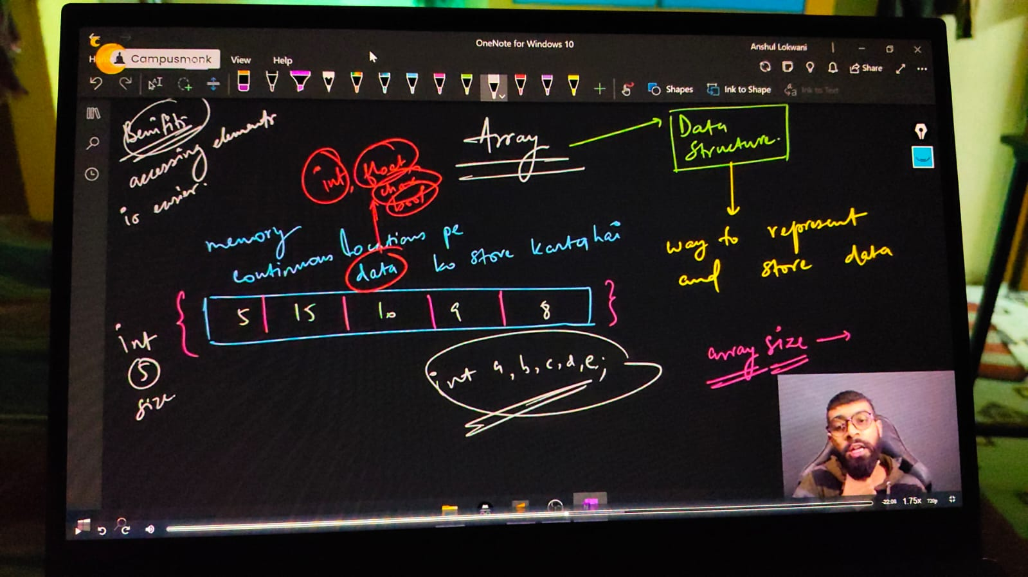

Array indexing concewpt –

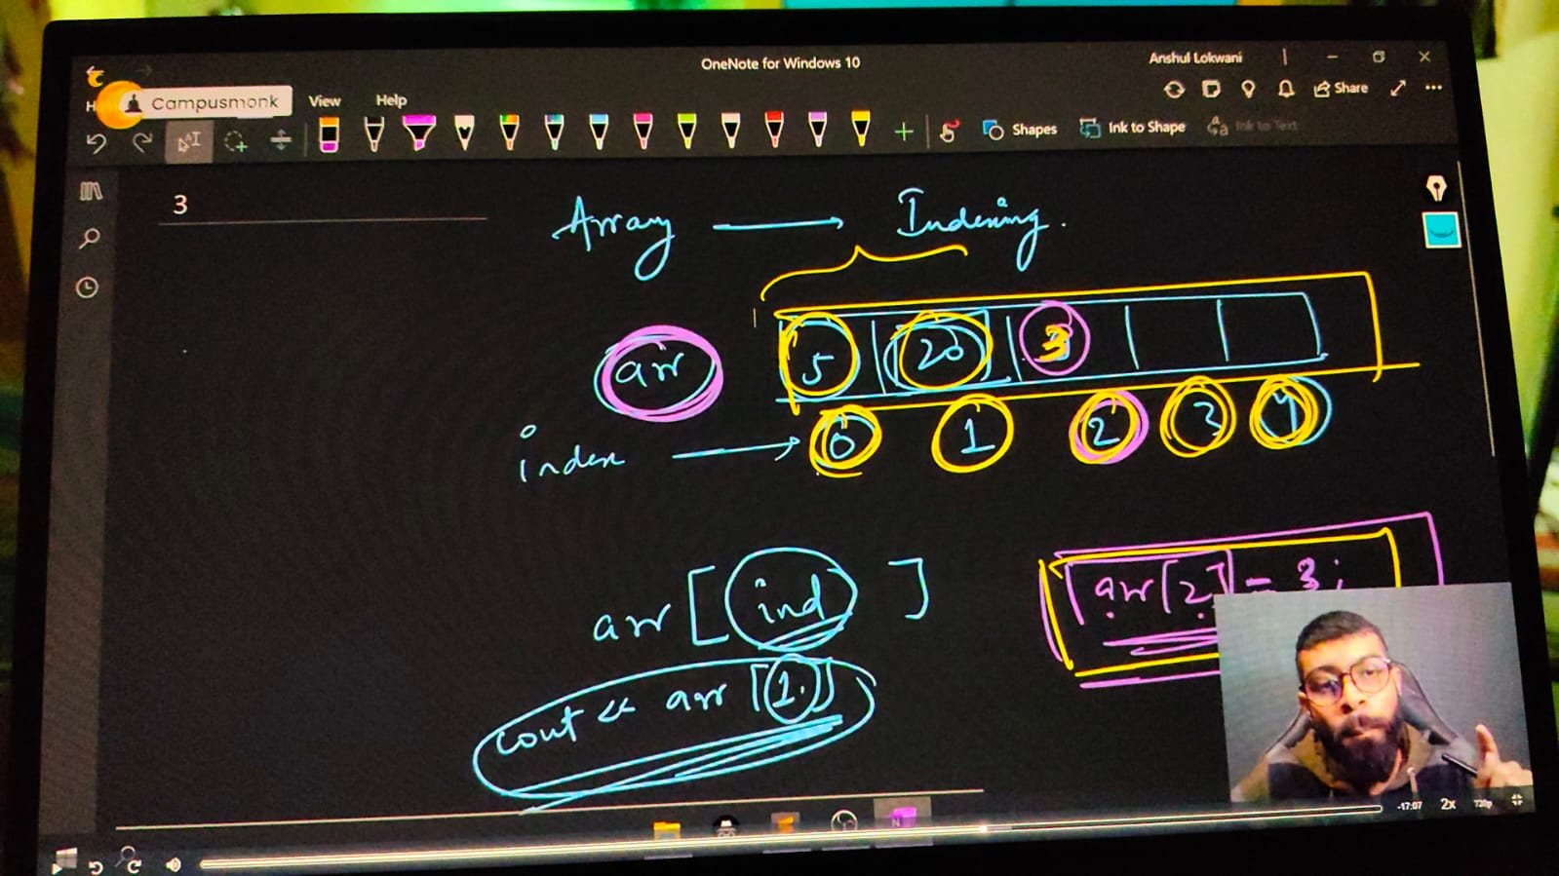

#include<iostream>

using namespace std;

int main()

{

    // Array in CPP -

    // Array declaration and array syntax -

    // DATATYPE ARRAY_NAME [Size]

    int arr[5];

    // initialization of an array -

    int arrr[6] = {6,5,4,3,2,1};

    // array printing

    /*

    cout<<arrr[0]<<endl;//6

    cout<<arrr[1]<<endl;//5

    cout<<arrr[2]<<endl;//4

    cout<<arrr[3]<<endl;//3

    cout<<arrr[4]<<endl;//2

    cout<<arrr[5]<<endl;//1

    cout<<arrr[6]<<endl;//6422280 - error as memory not specified so any bvalue produces toa avpid error

    */

    for (int i = 0; i <= 5; i++)

    {

        cout<<arrr[i]<<endl;

// ____________ ____________

**// Taking input for array size**

    // int size; cout<<"mrntion the size of arry you want to take for elements"<<endl; cin>>size;

    // int arey[size];

    // cout<<"Now enter the array values one by one"<<endl;

    // for (int j = 0; j < size; j++)

    // {

    //     cin>>arey[j];

    // }

    // cout<<"You entered array values as following - "<<endl;

    // for (int j = 0; j < size; j++)

    // {

    //     cout<<arey[j]<<endl;

    // }

// ____________ ____________

**// sun of array's elements**

    // int sum=0;

    // int aruy[5] = {10,20,30,40,50};

    // for (int k = 0; k < 5; k++)

    // {

    //     sum=sum+aruy[k];

    // }

    // cout<<sum<<endl;

    // ____________ ____________

**// Mltiplication of all elenewntds of an array**

    // int product=1;

    // int aruyy[5] = {10,20,30,40,50};

    // for (int k = 0; k < 5; k++)

    // {

    //     product=product*aruyy[k];

    // }

    // cout<<"So the multiplication result is - "<<product<<endl;

// ____________ ____________

**// Avg of an array**

    // int avg=0,summ=0;

    // int aruyyy[5] = {10,20,30,40,50};

    // for (int k = 0; k < 5; k++)

    // {

    //     summ=summ+aruyyy[k];

    //     avg = sum/5;

    // }

    // cout<<"So the sum  is - " <<summ<<" and the avg is - "<<avg<<endl;

// ____________ ____________

**// Now usign this sum/Ml/Avg printing approach by taking input from the user manualy**

    // int size;

    // cout<<"Enter the size of array you wwant"<<endl;

    // cin>>size;

    // int arrey[size];

    // cout<<"It's  time to enter the values of your array dude"<<endl;

    // for (int i = 0; i < size; i++)

    // {

    //     cin>>arrey[i];

    // }

    // cout<<"So the insereted eleemnts are - "<<endl;

    // for (int j = 0; j < size; j++)

    // {

    //     cout<<arrey[j]<<endl;

    // }

    // int totalsum=0, mul=1,avgg=0;

    // for (int k = 0; k < size; k++)

    // {

    //     totalsum = totalsum+arrey[k];

    //     mul=mul*arrey[k];

    //     avgg = float(totalsum/size);

    // }

    // cout<<" The sum of inserted elements is "<<totalsum<<endl;

    // cout<<" So the multiplication result is - "<<mul<<endl;

    // cout<<" and the most epic avg of elements is "<<avgg<<endl;

// ____________ ____________ ____________ ____________ ____________

// Array Basic QUnstions -

**// 1) - Min. Element from Array**

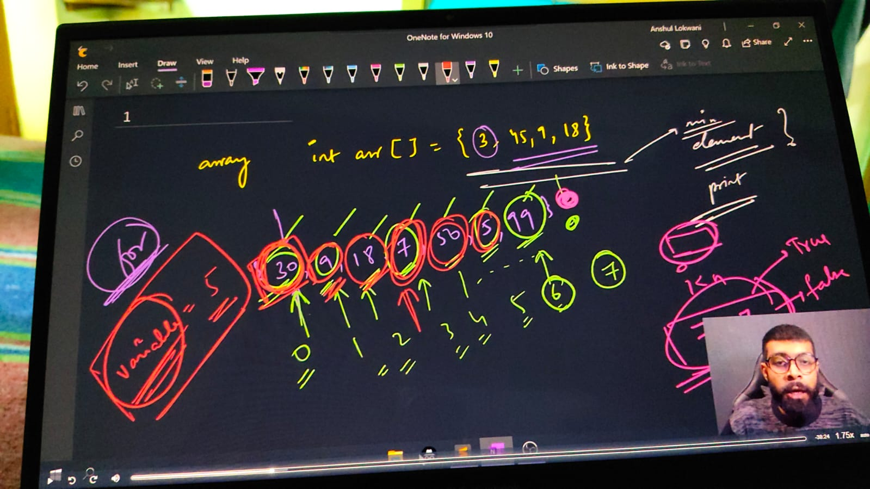

// int n;

    // cout << "ENtert no. of elements in your array " << endl;

    // cin >> n;

    // int arr1[n];

    // cout<<"Enter elements of an array - "<<endl;

    // for (int i = 0; i < n; i++)

    // {

    //     cin >> arr1[i];//15,2,89,75,63

    // }

    // // for min. element among all

    // int minelmnt = arr1[0];

    // for (int i = 0; i < n; i++)

    // {

    //     if (arr1[i] < minelmnt)

    //     {

    //         minelmnt = arr1[i];

    //     }

    // }

    // cout << "Min element among this is - " << minelmnt << endl;// - 2

// ____________ ____________ ____________ ____________ ____________

**// 2) - Max. Element from array -**

    // int n;

    // cout << "ENtert no. of elements in your array " << endl;

    // cin >> n;

    // int arr2[n];

    // for (int i = 0; i < n; i++)

    // {

    //     cin >> arr2[i];//15,2,89,75,63

    // }

    // // Max eleemnt  -

    // int maxelemnt = arr2[0];

    // for (int i = 0; i < n; i++)

    // {

    //     if (arr2[i] > maxelemnt)

    //     {

    //         maxelemnt = arr2[i];

    //     }

    // }

    // cout << "Maximum element is - " << maxelemnt << endl;// - 89

    // These two quns were about aRRAY traverse or array iterate

// ____________ ____________ ____________ ____________ ____________

**// 3) FInd any element present in the array or not**

    // int n;

    // cout << "ENtert no. of elements in your array " << endl;

    // cin >> n;

    // int arr1[n];

    // for (int i = 0; i < n; i++)

    // {

    //     cout<<"Enter the "<<i<<" element value "<<endl;

    //     cin >> arr1[i];

    // }

    // // Find ELement  -

    // int searchingelement = 50;

    // // cout<<"Enter the elemnt you want to search"<<endl;

    // // cin>>searchingelement;

    // for (int i = 0; i < n; i++)

    // {

    //     if (arr1[i] == searchingelement)

    //     {

    //         cout<<"Element "<<searchingelement<<" found successfully at indexing "<<i<<endl;

    //         return 0;

    //     }

    // }

    // cout<<"Sorry Beaste, Elment you wewre looking for din't found"<<endl;

// ____________ ____________ ____________ ____________ ____________

**// 4) FInd elemnt at which indexing -**

    // int n; cout<<"What is the size of an array"<<endl;

    // cin>>n;

    // int arru[n];

    // cout<<"Give the array elementts"<<endl;

    // for (int i = 0; i < n; i++)

    // {

    //     cin>>arru[i];

    // }

    // int x; cout<<"x you wnat to search for "<<endl;

    // cin>>x;

    // for (int i = n-1; i >= 0; i--) //or for(int i=0; i<n; i++) - its just another ways for iterating inside an array

    // {

    //     if (arru[i] == x)

    //     {

    //         cout<<"found at indexing "<<i<<endl; // If element exist multiple times it'll give indexing for each time

    //     }

    // }

    // return -1;

// ____________ ____________

**// 4.1) Find FIrst index of element searched**

    // int n; cout<<"What is the size of an array"<<endl;

    // cin>>n;

    // int arru[n];

    // cout<<"Give the array elementts"<<endl;

    // for (int i = 0; i < n; i++)

    // {

    //     cin>>arru[i];

    // }

    // int x; cout<<"x you wnat to search for "<<endl;

    // cin>>x;

    // for(int i=0; i<n; i++) //or  - for getting the indexing from last

    // {

    //     if (arru[i] == x)

    //     {

    //         cout<<"found at indexing "<<i<<endl; // If element exist multiple times it'll give only for the first indexing as we programmed

    //         return 0;

    //     }

    // }

    // return -1;

/*

O/p -

What is the size of an array

5

Give the array elementts

89

45

89

78

23

x you wnat to search for

89

found at indexing 0

*/

// ____________ ____________

**// 4.2) Find last index of element searched**

    // int n; cout<<"What is the size of an array"<<endl;

    // cin>>n;

    // int arru[n];

    // cout<<"Give the array elementts"<<endl;

    // for (int i = 0; i < n; i++)

    // {

    //     cin>>arru[i];

    // }

    // int x; cout<<"x you wnat to search for "<<endl;

    // cin>>x;

    // for (int i = n-1; i >= 0; i--) // for getting the indexing from last

    // {

    //     if (arru[i] == x)

    //     {

    //         cout<<"found at indexing "<<i<<endl; // If element exist multiple times it'll give only for the first indexing as we programmed

    //         return 0;

    //     }

    // }

    // return -1;

/*

O/p -

What is the size of an array

5

Give the array elementts

89

45

89

78

23

x you wnat to search for

89

found at indexing 2

*/

**// OR METHOD 2 - MAIN METHOD**

// int n; cout<<"What is the size of an array"<<endl;

//     cin>>n;

//     int arru[n];

//     cout<<"Give the array elementts"<<endl;

//     for (int i = 0; i < n; i++)

//     {

//         cin>>arru[i];

//     }

//     int x; cout<<"x you wnat to search for "<<endl;

//     cin>>x;

//     int index = -1;

//     for(int i=0; i<n; i++)

//     {

//         if (arru[i] == x)

//         {

//             index = i; // For getting indexing from last updating

//         }

//     }

//     cout<<index<<endl;

/*

What is the size of an array

5

Give the array elementts

89

45

89

78

89

x you wnat to search for

89

4

*/

// ____________ ____________ ____________ ____________ ____________

**// 5) Find Frequency of x in array - howe many times any element is repeating**

int n; cout<<"What is the size of an array"<<endl;

cin>>n;

int arru[n];

cout<<"Give the array elementts"<<endl;

for (int i = 0; i < n; i++)

{

    cin>>arru[i];

}

int x; cout<<"x you wnat to search for "<<endl;

cin>>x;

int gotit=0;

for(int i=0; i<n; i++)

{

    if (arru[i] == x)

    {

        gotit++;

    }

}

cout<<"frequency of element is - "<<gotit<<endl;

/*

What is the size of an array

5

Give the array elementts

89

78

89

45

89

x you wnat to search for

89

frequency of element is - 3

*/

**Reverse and Sorting of an Array**

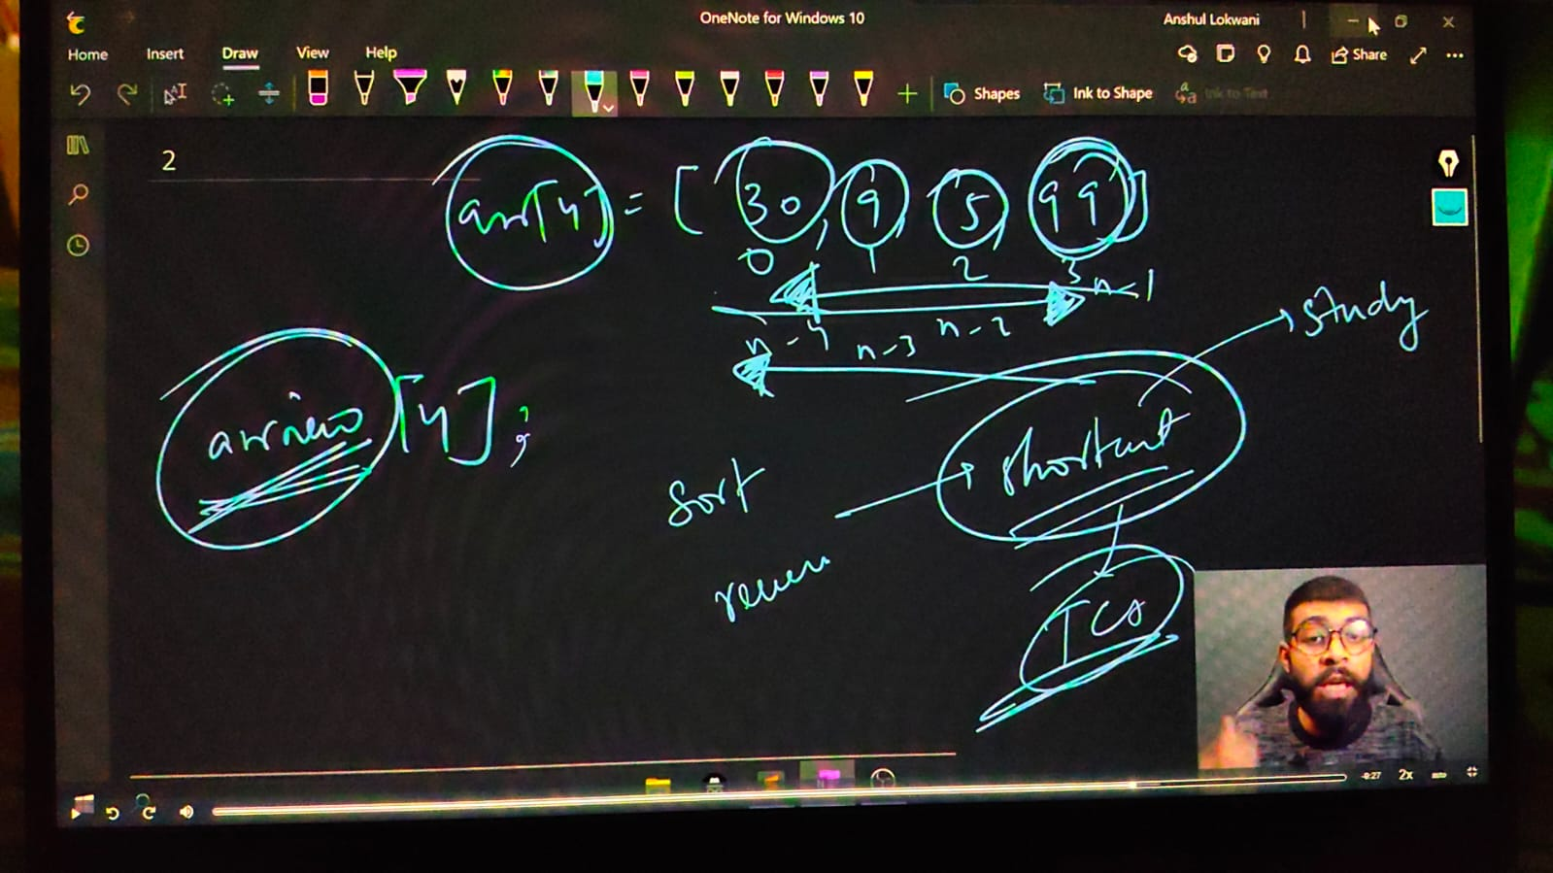

// For reversing an array we must include a header file named as algorithms

    int n; cout<<"What is the size of an array"<<endl;

    cin>>n;

    int arru[n];

    cout<<"Give the array elementts"<<endl;

    for (int i = 0; i < n; i++)

    {

        cin>>arru[i];

    }

    // For Reverseing an array -

    // Syntax for reverse - reverse(ARRAYNAME, ARRAYNAME+ARRAYSIZE)

    // Modified syntax as per trials - reverse(ARRAYNAME+jaha tk reverse krna ho, ARRAYNAME+jaha se reverse krna ho)

    // reverse(arru, arru+n);

    // for (int i = 0; i < n; i++)

    // {

    //     cout<<arru[i]<<" ";

    // }

/*

What is the size of an array

5

Give the array elementts

15

89

23

78

56

56 78 23 89 15

*/

// ____________ ____________ ____________ ____________ ____________

**// 6.1) For sorting an array -**

// Syntax for sort - sort(ARRAYNAME, ARRAYNAME+ARRAYSIZE)

// Modified syntax as per trials - sort(ARRAYNAME+jaha tk sort krna ho, ARRAYNAME+jaha se sort krna ho)

// sort(arru, arru+n);

// for (int i = 0; i < n; i++)

// {

//     cout<<arru[i]<<" ";

// }

/*

What is the size of an array

5

Give the array elementts

89

78

56

21

45

21 45 56 78 89

*/

// ____________ ____________

//  for sorting in decreasing order. First sort then usereverse

// sort(arru, arru+n);

// reverse(arru, arru+n);

// for (int i = 0; i < n; i++)

// {

//     cout<<arru[i]<<" ";

// }

/*

What is the size of an array

5

Give the array elementts

45

98

100

20

78

100 98 78 45 20

*/

// ____________ ____________

**// Min & Max using Sort in Array -**

// sort(arru, arru+n);

// for (int i = 0; i < n; i++)

// {

//     cout<<arru[i]<<" ";

// }

// cout<<endl;

// cout<<"Min is  "<<arru[0]<<endl;

// cout<<"MaX is  "<<arru[n-1]<<endl;

/*

What is the size of an array

5

Give the array elementts

89

32

56

12

47

12 32 47 56 89

Min is  12

MaX is  89

*/

// ____________ ____________

**//  Find kth Max & Kth Min in Array -**

// sort(arru, arru+n);

// int k;

// cout<<"Which max or min element you want to get"<<endl;

// cin>>k;

// sort(arru, arru+n);

// for (int i = 0; i < n; i++)

// {

//     cout<<arru[i]<<" ";

// }

// cout<<endl;

// cout<<k<<"th Minimun element is "<<arru[k-1]<<endl;

// cout<<k<<"th Maximum element is "<<arru[n-k]<<endl;

/*

What is the size of an array

5

Give the array elementts

12

56

78

32

99

Which max or min element you want to get

2

12 32 56 78 99

2th Minimun element is 32

2th Maximum element is 78

*/

**// What if the Interviewer yold that you can;t use Sort or inbuilt library functions. Method 2 for kth Min & kth Max –**

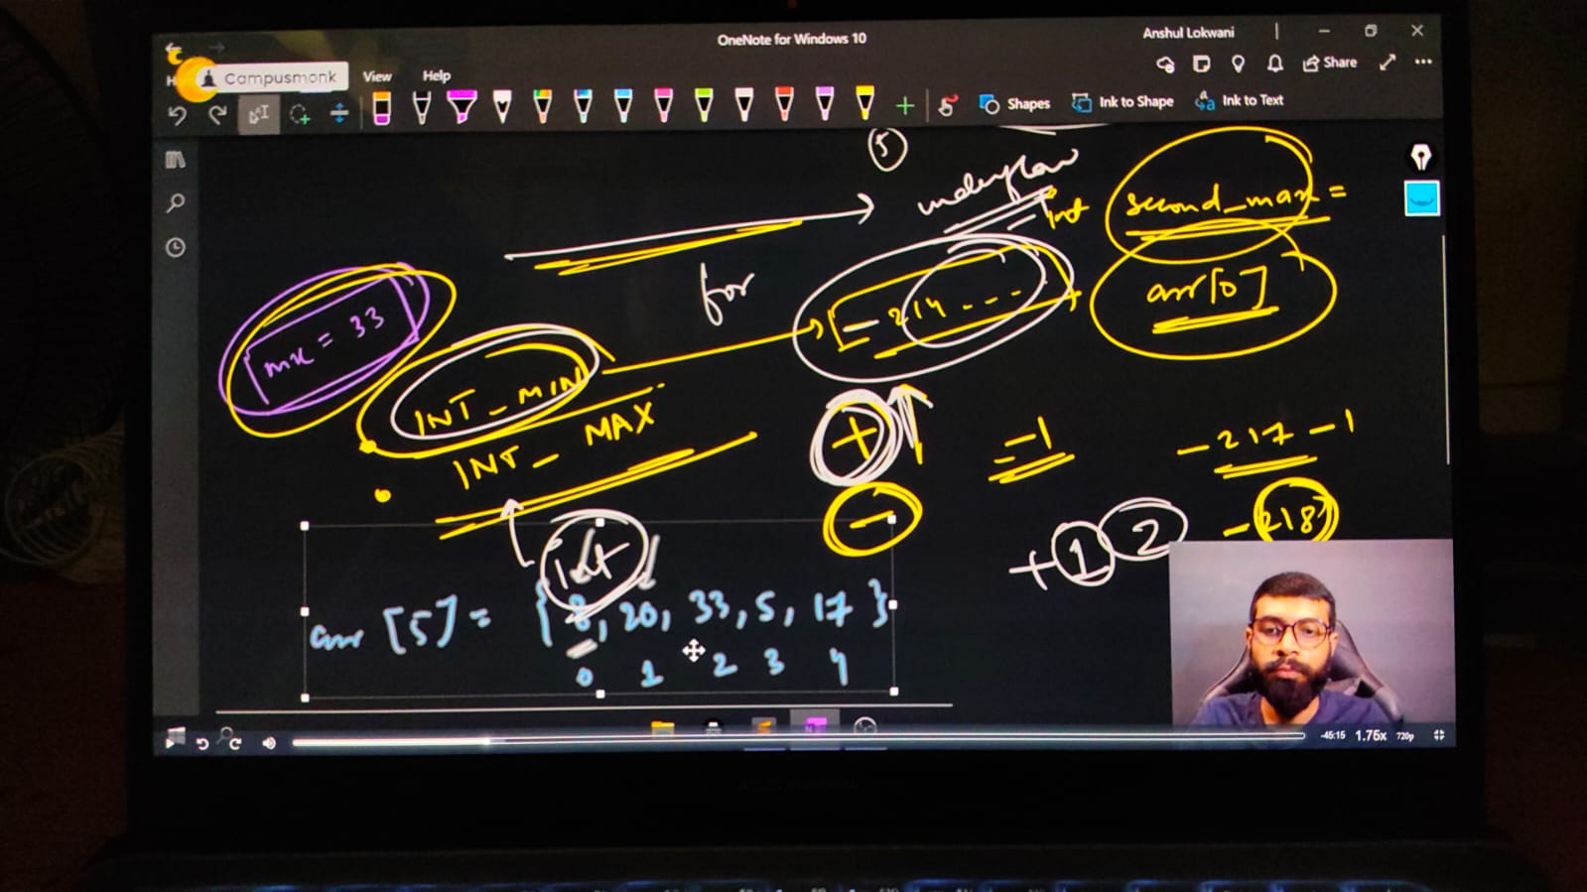

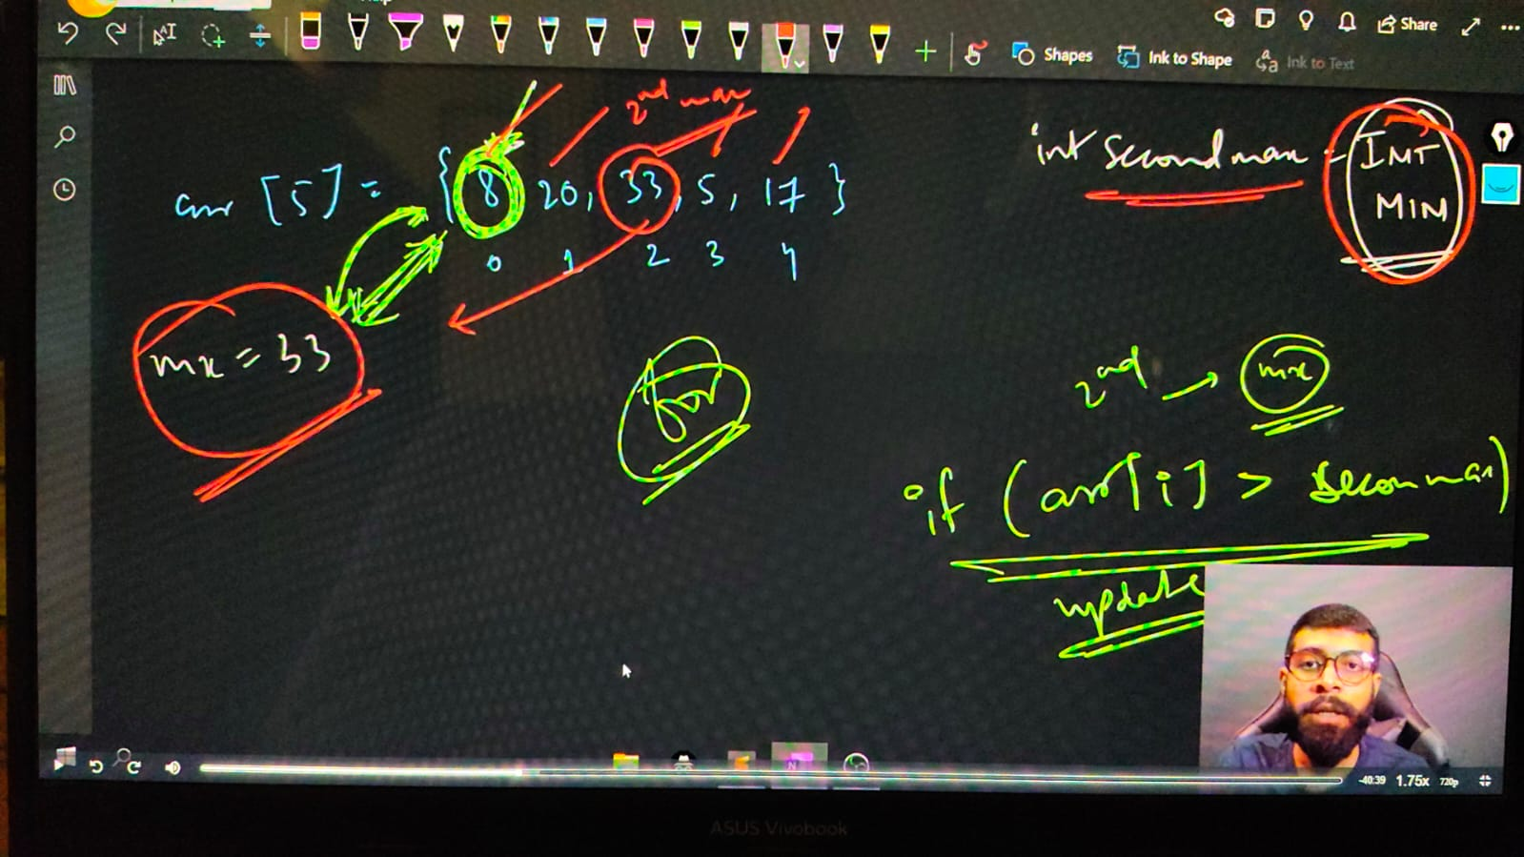

**// For the 2nd max fun**

    // int n;

    // cout<<"Mention the size of an array"<<endl;

    // cin>>n;

    // int arr[n];

    // cout<<"Insrt the array elements - "<<endl;

    // for (int i = 0; i < n; i++)

    // {

    //     cin>>arr[i];

    // }

    // cout<<"So, the entered array is - "<<endl;

    // for (int i = 0; i < n; i++)

    // {

    //     cout << arr[i] <<" ";

    // }

    // cout<<endl;

    // // For the first max

    // int mx = arr[0];

    // for (int i = 0; i < n; i++)

    // {

    //     if (arr[i]>mx)

    //     {

    //         mx=arr[i];

    //     }

    // }

    // cout<<"The Maximuum element is "<<mx<<endl;

    // // For the second max

    // int secondmax = INT_max;

    // for (int i = 0; i < n; i++)

    // {

    //     if (arr[i] != mx)

    //     {

    //         if (arr[i]>secondmax)

    //         {

    //             secondmax = arr[i];

    //         }

    //     }

    // }

    // cout<<"So, the second max element is - "<<secondmax<<endl;

/*

Mention the size of an array

5

Insrt the array elements -

78

89

56

12

23

So, the entered array is -

78 89 56 12 23

The Maximuum element is 89

So, the second max element is - 78

*/

// ____________ ____________

**// For the 2nd max -**

    // int n;

//     cout<<"Mention the size of an array"<<endl;

//     cin>>n;

//     int arr[n];

//     cout<<"Insrt the array elements - "<<endl;

//     for (int i = 0; i < n; i++)

//     {

//         cin>>arr[i];

//     }

//     cout<<"So, the entered array is - "<<endl;

//     for (int i = 0; i < n; i++)

//     {

//         cout << arr[i] <<" ";

//     }

//     cout<<endl;

//     // For the first max

//     int max = arr[0];

//     for (int i = 0; i < n; i++)

//     {

//         if (arr[i]<max)

//         {

//             max=arr[i];

//         }

//     }

//     cout<<"The maximum element is "<<max<<endl;

//     // For the second max

//     int secondmax = INT_MAX;

//     for (int i = 0; i < n; i++)

//     {

//         if (arr[i] != max)

//         {

//             if (arr[i]<secondmax)

//             {

//                 secondmax = arr[i];

//             }

//         }

//     }

//     cout<<"So, the second max element is - "<<secondmax<<endl;

/*

Mention the size of an array

5

Insrt the array elements -

78

89

56

12

23

So, the entered array is -

78 89 56 12 23

The maximum element is 12

So, the second max element is - 23

*/

// ____________ ____________ ____________ ____________ ____________

**// Similarly for 3rd Max**

int n;

    cout<<"Mention the size of an array"<<endl;

    cin>>n;

    int arr[n];

    cout<<"Insrt the array elements - "<<endl;

    for (int i = 0; i < n; i++)

    {

        cin>>arr[i];

    }

    cout<<"So, the entered array is - "<<endl;

    for (int i = 0; i < n; i++)

    {

        cout << arr[i] <<" ";

    }

    cout<<endl;

    // For the first max

    int max = arr[0];

    for (int i = 0; i < n; i++)

    {

        if (arr[i]>max)

        {

            max=arr[i];

        }

    }

    cout<<"The maximum element is "<<max<<endl;

    // For the second max

    int secondmax = INT_MIN;

    for (int i = 0; i < n; i++)

    {

        if (arr[i] != max)

        {

            if (arr[i]>secondmax)

            {

                secondmax = arr[i];

            }

        }

    }

    cout<<"So, the second max element is - "<<secondmax<<endl;

    // For the third max

    int thirddmax = INT_MIN;

    for (int i = 0; i < n; i++)

    {

        if (arr[i] != secondmax && arr[i] != max)

        {

            if (arr[i]>thirddmax)

            {

                thirddmax = arr[i];

            }

        }

    }

    cout<<"So, the third max element is - "<<thirddmax<<endl;

/*

Mention the size of an array

5

Insrt the array elements -

89

78

56

12

23

So, the entered array is -

89 78 56 12 23

The maximum element is 89

So, the second max element is - 78

So, the third max element is - 56

*/

// ____________ ____________

**// Similarly for 3rd min**

//     int n;

//     cout<<"Mention the size of an array"<<endl;

//     cin>>n;

//     int arr[n];

//     cout<<"Insrt the array elements - "<<endl;

//     for (int i = 0; i < n; i++)

//     {

//         cin>>arr[i];

//     }

//     cout<<"So, the entered array is - "<<endl;

//     for (int i = 0; i < n; i++)

//     {

//         cout << arr[i] <<" ";

//     }

//     cout<<endl;

//     // For the first max

//     int max = arr[0];

//     for (int i = 0; i < n; i++)

//     {

//         if (arr[i]<max)

//         {

//             max=arr[i];

//         }

//     }

//     cout<<"The maximum element is "<<max<<endl;

//     // For the second max

//     int secondmax = INT_MAX;

//     for (int i = 0; i < n; i++)

//     {

//         if (arr[i] != max)

//         {

//             if (arr[i]<secondmax)

//             {

//                 secondmax = arr[i];

//             }

//         }

//     }

//     cout<<"So, the second max element is - "<<secondmax<<endl;

//     // For the third max

//     int thirddmax = INT_MAX;

//     for (int i = 0; i < n; i++)

//     {

//         if (arr[i] != secondmax && arr[i] != max)

//         {

//             if (arr[i]<thirddmax)

//             {

//                 thirddmax = arr[i];

//             }

//         }

//     }

//     cout<<"So, the third max element is - "<<thirddmax<<endl;

/*

Mention the size of an array

Mention the size of an array

5

Insrt the array elements -

78

89

56

12

23

So, the entered array is -

78 89 56 12 23

The maximum element is 12

So, the second max element is - 23

So, the third max element is - 56

*/

// ____________ ____________ ____________ ____________ ____________ ____________ ____________ ____________ ____________ ____________ ____________

**// 7) QUn - Targeted Element. Print yes if there is a  pair in the array that sum up to target. Array ke kisi element ya kinhi bhi elements ka sum target ke brabr he to yes kre**

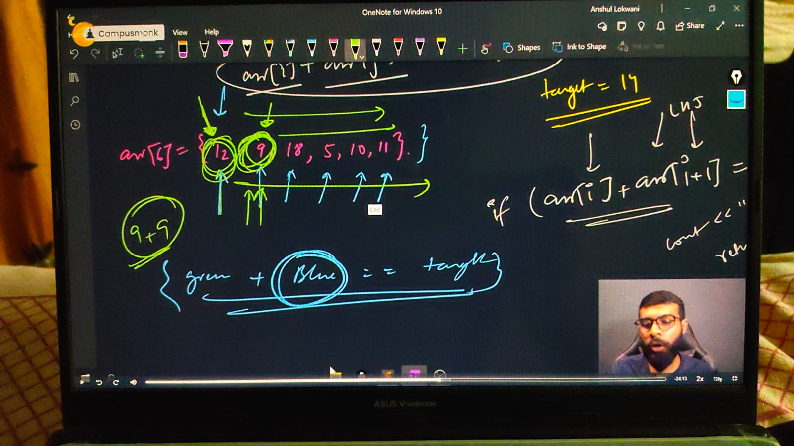

#include <iostream>

using namespace std;

int main()

{

    int n;

    cout << "mention the array size you want" << endl;

    cin >> n;

    int arr[n];

    cout << "Enter the array elements going to print - " << endl;

    for (int i = 0; i < n; i++)

    {

        cin >> arr[i];

    }

    cout << "So, the entered array is - " << endl;

    for (int i = 0; i < n; i++)

    {

        cout << arr[i] << " ";

    }

    cout << endl;

    int target;

    cout << "WHat value you want to target - " << endl;

    cin >> target;

    for (int i = 0; i < n; i++)

    {

        for (int j = i+1; j < n; j++)

        {

            if (arr[i] + arr[j] == target)

            {

                cout << "Got the target and elementts are  - " << arr[i] << " " << arr[j] << endl;

                return 0;

            }

        }

    }

    cout << "Not found the targetby array elements";

}

/* o/p -

mention the array size you want

5

Enter the array elements going to print -

56 89 12 45 78

So, the entered array is -

56 89 12 45 78

WHat value you want to target -

57

Got the target and elementts are  - 12 45

____________ ____________

mention the array size you want

5

Enter the array elements going to print -

89 56 32 21 54

So, the entered array is -

89 56 32 21 54

WHat value you want to target -

78

Not found the targetby array elements

*/

// ____________ ____________ ____________ ____________ ____________

**// 8) Qun - For given 2 arrays, find Union & Intersection**

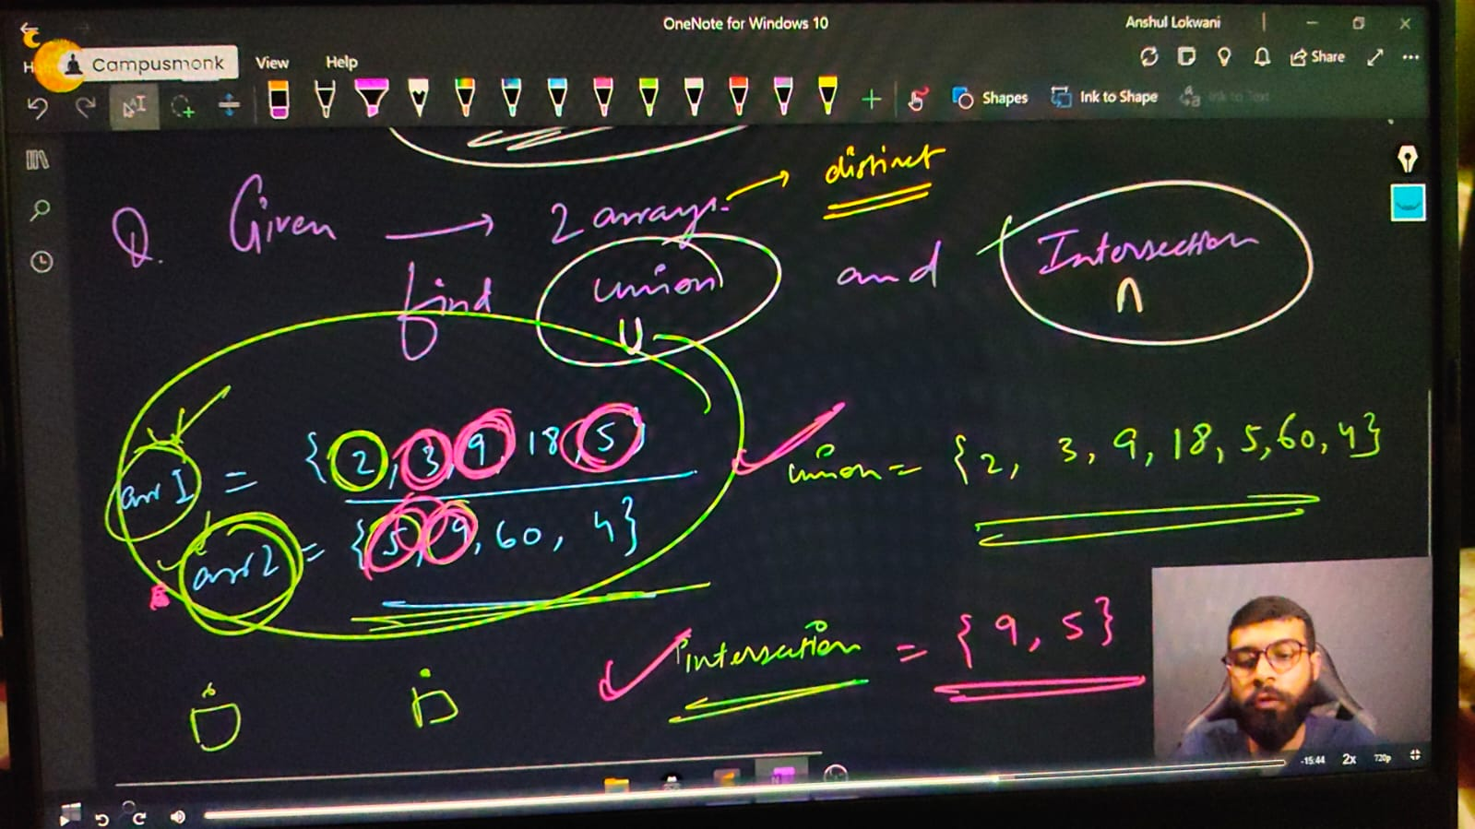

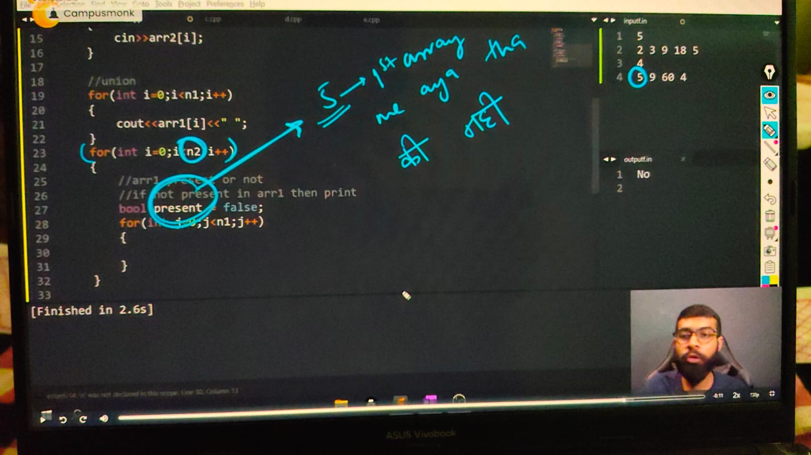

    int n1, n2;

    cout << "mention the array1 size " << endl;

    cin >> n1;

    cout << "mention the array2 size respectively" << endl;

    cin >> n2;

    int arr1[n1];

    int arr2[n2];

    cout << "Enter the array1 elements going to print - " << endl;

    for (int i = 0; i < n1; i++)

    {

        cin >> arr1[i];

    }

    cout << endl;

    cout << "and similarly Enter the array2 elements going to print - " << endl;

    for (int i = 0; i < n2; i++)

    {

        cin >> arr2[i];

    }

    cout << endl;

    // For union -

    for (int i = 0; i < n1; i++)

    {

        cout << arr1[i] << " ";

    }

    for (int i = 0; i < n2; i++)

    {

        // in arr1 check for present or not

        // if not present in arr1 then print

        bool present = false; // prsent is uses for 1st waale array me aaya he ya nahi

        for (int j = 0; j < n1; j++)

        {

            if (arr2[i] == arr1[j])

            {

                present = true;

            }

        }

        if (present == false)

        {

            cout << arr2[i] << " ";

        }

    }

    cout<<endl;

    // Intersection -

    for (int i = 0; i < n1; i++)

    {

        for (int j = 0; j < n2; j++)

        {

            if (arr1[i] == arr2[j])

            {

                cout << arr1[i] << " ";

            }

        }

    }

    cout << endl;

mention the array1 size

5

mention the array2 size respectively

2 3 9 18 5

Enter the array1 elements going to print -

4

and similarly Enter the array2 elements going to print -

5 9 60 4

2 3 9 18 5 4

9 5

// ____________ ____________ ____________ ____________ ____________

**// 9) Qun - Find majority element if any.**

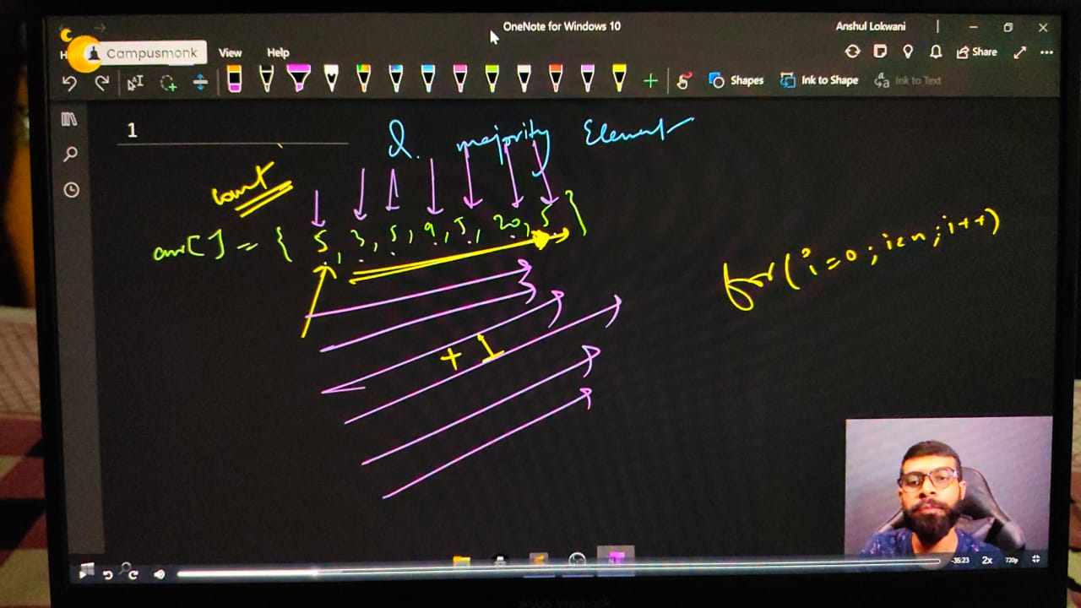

/*Note - majority elekent is given by > size of array/2

Majority Element  > {(Size of Array)/2} Ex. = arr[] = {5,3,5,9,5,18,5}

Majority element 1 hi ho skta h kyuki aadhe se jyadqa baar ek single element available he.

*/

// int n;

// cout<<"mention the array size you want"<<endl;

// cin>>n;

// int arr[n];

// cout<<"Enter the array elements going to print - "<<endl;

// for (int i = 0; i < n; i++)

// {

//     cin>>arr[i];

// }

// cout<<"So, the entered array is - "<<endl;

// for (int i = 0; i < n; i++)

// {

//     cout<<arr[i]<<" ";

// }

// cout<<endl;

// // CHekcing for majority element -

// for (int i = 0; i < n; i++)

// {

//     int count = 0;

//     for (int j = 0; j < n; j++)

//     {

//         if (arr[i]==arr[j])

//         {

//             count++;

//         }

//     }

//     if (count>n/2)

//     {

//         cout<<arr[i]<<endl;

//         return 0;

//     }

// }

// cout<<"Sorry, No Majjority Eleelment found dude"<<endl;

/*

mention the array size you want

7

Enter the array elements going to print -

5 3 5 9 5 20 5

So, the entered array is -

5 3 5 9 5 20 5

5

*/

// ____________ ____________

/*

**Method - 2**

Majority candidate can done by sorting the array because after this middle element will be the majority element.

Agr sorting ke baad middle element majority element nhi hua to phr koi sa nhi ho skta

*/

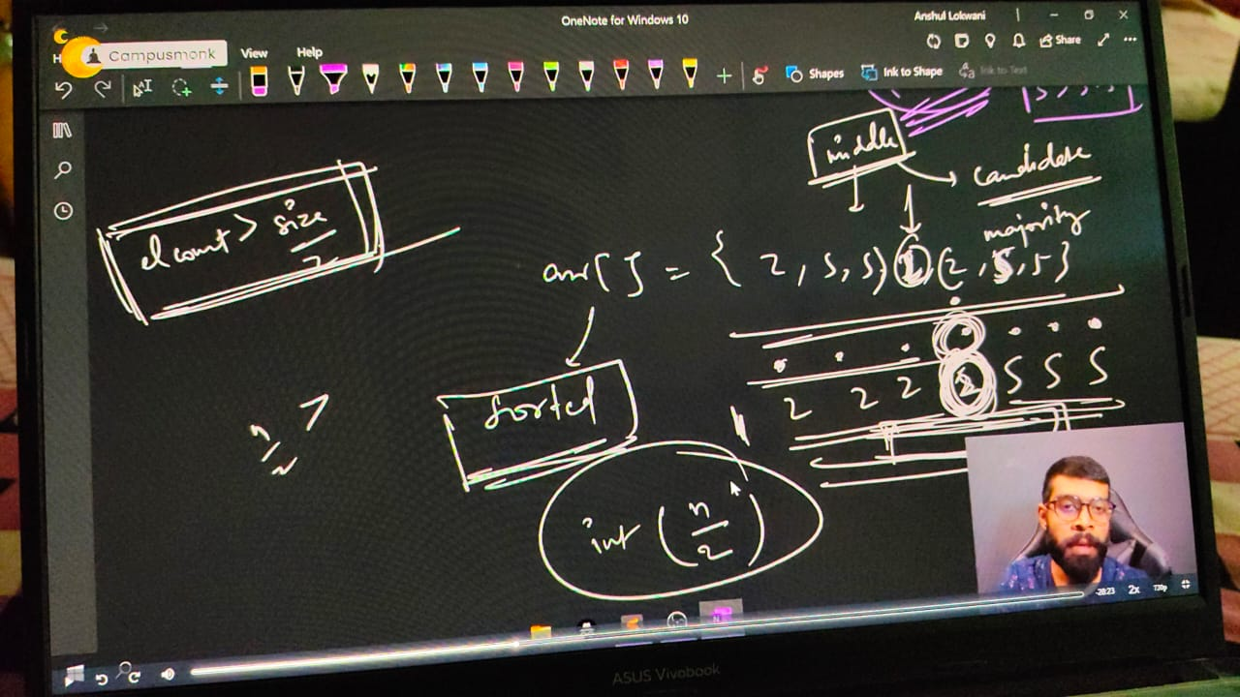

// int n;

// cout<<"mention the array size you want"<<endl;

// cin>>n;

// int arr[n];

// cout<<"Enter the array elements going to print - "<<endl;

// for (int i = 0; i < n; i++)

// {

//     cin>>arr[i];

// }

// cout<<endl;

// // CHekcing for majority element -

// sort(arr, arr+n);

// int expectedcandidate = arr[n/2];

// int count = 0;

// for (int i = 0; i < n; i++)

// {

//     if (arr[i]==expectedcandidate)

//     {

//         count++;

//     }

// }

//     if (count>n/2)

//     {

//         cout<<"The Majority candidarte is - "<<expectedcandidate<<endl;

//     }

//     else

// {

//     cout<<"No Majority element availabe";

// }

/* o/p -

mention the array size you want

7

Enter the array elements going to print -

5 3 5 9 5 18 5

The Majority candidarte is – 5

*/

// ____________ ____________ ____________ ____________ ____________

**// 10) Rotating array concept -**

**// 10.1)Right Rotation - Rotate each eleemnt by one in th eRight side**

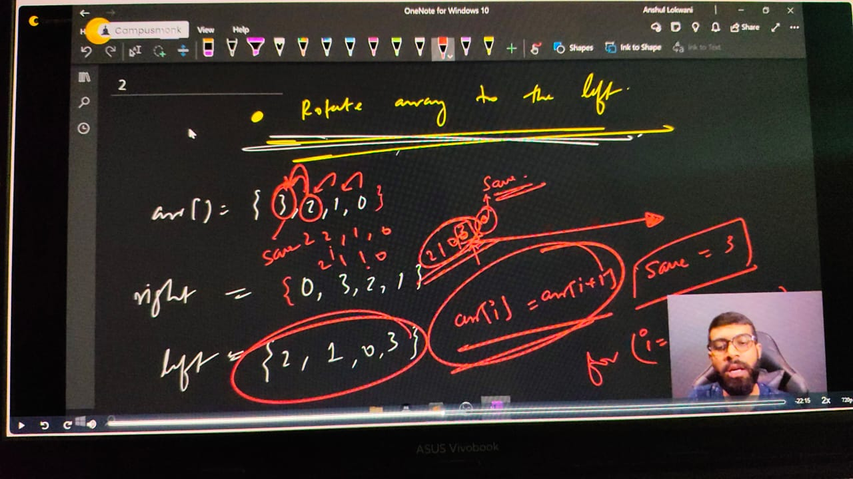

// int n;

//     cout << "Array Size: ";

//     cin >> n;

//     int arr[n];

//     cout << "Array Values:\n";

//     for (int i = 0; i < n; i++) {

//         cin >> arr[i];

//     }

//     cout << "Your array is: ";

//     for (int i = 0; i < n; i++) {

//         cout << arr[i] << " ";

//     }

//     cout << endl;

//     // Right Rotation Logic

//     int save = arr[n - 1]; // Save the last element

//     for (int i = n - 1; i > 0; i--) {

//         arr[i] = arr[i - 1]; // Shift all elements right

//     }

//     arr[0] = save; // Put last element at the front

//     cout << "Hence, the new Right Rotated Array is: ";

//     for (int i = 0; i < n; i++) {

//         cout << arr[i] << " ";

//     }

//     cout << endl;

//     return 0;

/*

Array Size: 5

Array Values:

1 2 3 4 5

Your array is: 1 2 3 4 5

Hence, the new Right Rotated Array is: 5 1 2 3 4

*/

**// 10.1)Left Rotation - Rotate each eleemnt by one in th eleft side**

    // int n;

    // cout<<"Array SIze"<<endl;

    // cin>>n;

    // int arr[n];

    // cout<<"Array Values"<<endl;

    // for (int i = 0; i < n; i++)

    // {

    //     cin>>arr[i];

    // }

    // cout<<"your array is - ";

    // for (int i = 0; i < n; i++)

    // {

    //     cout<<arr[i]<<" ";

    // }

    // cout<<endl;

    // // For Left Rotation -

    // int save = arr[0];

    // for (int i = 0; i < n; i++)

    // {

    //     arr[i] = arr[i+1];

    // }

    // arr[n-1] = save;

    // cout<<"Hence, the new Left Rotated Array is -  ";

    // for (int i = 0; i < n; i++)

    // {

    //     cout<<arr[i]<<" ";

    // }

/*

Array SIze

4

Array Values

3 2 1 0

your array is - 3 2 1 0

Hence, the new Left Rotated Array is -  2 1 0 3

*/

// ____________ ____________

**//10.3)  WHat if wants to rotate lefyt three times.**

    // int n;

    // cout<<"Array SIze"<<endl;

    // cin>>n;

    // int arr[n];

    // cout<<"Array Values"<<endl;

    // for (int i = 0; i < n; i++)

    // {

    //     cin>>arr[i];

    // }

    // cout<<"your array is - ";

    // for (int i = 0; i < n; i++)

    // {

    //     cout<<arr[i]<<" ";

    // }

    // cout<<endl;

    // // For Left Rotation -

    // int save = arr[0];

    // for (int i = 0; i < n; i++)

    // {

    //     arr[i] = arr[i+1];

    // }

    // arr[n-1] = save;

    // cout<<"After 1st rotation "<<endl;

    // for (int i = 0; i < n; i++)

    // {

    //     cout<<arr[i]<<" ";

    // }

    // cout<<endl;

    // // For 2nd left rotation -

    // int save1 = arr[0];

    // for (int i = 0; i < n; i++)

    // {

    //     arr[i] = arr[i+1];

    // }

    // arr[n-1] = save1;

    // cout<<"After 2nd rotation "<<endl;

    // for (int i = 0; i < n; i++)

    // {

    //     cout<<arr[i]<<" ";

    // }

    // cout<<endl;

    // // For 3rd left rotation -

    // int save3 = arr[0];

    // for (int i = 0; i < n; i++)

    // {

    //     arr[i] = arr[i+1];

    // }

    // arr[n-1] = save3;

    // cout<<"After 3rd rotation "<<endl;

    // for (int i = 0; i < n; i++)

    // {

    //     cout<<arr[i]<<" ";

    // }

    // cout<<endl;

    // cout<<"Hence, the new Left Rotated Array is -  ";

    // for (int i = 0; i < n; i++)

    // {

    //     cout<<arr[i]<<" ";

    // }

/*

Array SIze

5

Array Values

1 2 3 4 5

your array is - 1 2 3 4 5

After 1st rotation

2 3 4 5 1

After 2nd rotation

3 4 5 1 2

After 3rd rotation

4 5 1 2 3

Hence, the new Left Rotated Array is -  4 5 1 2 3

*/

// ____________ ____________

**// Using function can be done very easily -**

/*

#include <bits/stdc++.h>

using namespace std;

void left_rotate(int arr[], int n)

{

    int save = arr[0];

    for (int i = 0; i < n-1; i++)

    {

        arr[i] = arr[i+1];

    }

    arr[n-1] = save;

}

int main()

{

    int n;

    cout<<"Array Size"<<endl;

    cin>>n;

    int arr[n];

    cout<<"Array Elements - "<<endl;

    for (int i = 0; i < n; i++)

    {

        cin>>arr[i];

    }

    cout<<"So, your entered array is - "<<endl;

    for (int i = 0; i < n; i++)

    {

        cout<<arr[i]<<" ";

    }

    cout<<endl;

    left_rotate(arr,n);

    left_rotate(arr,n);

    left_rotate(arr,n);

    cout<<"So, the new rotated array is - "<<endl;

    for (int i = 0; i < n; i++)

    {

        cout<<arr[i]<<" ";

    }

*/

/*

Array Size

5

Array Elements -

1 2 3 4 5

So, your entered array is -

1 2 3 4 5

So, the new rotated array is -

4 5 1 2 3

*/

// ____________ ____________

**// Similarly for k times as per the need -**

// void left_rotate(int arr[], int n)

// {

//     int save = arr[0];

//     for (int i = 0; i < n-1; i++)

//     {

//         arr[i] = arr[i+1];

//     }

//     arr[n-1] = save;

// }

// int main()

// {

//     int n;

//     cout<<"Array Size"<<endl;

//     cin>>n;

//     int arr[n];

//     cout<<"Array Elements - "<<endl;

//     for (int i = 0; i < n; i++)

//     {

//         cin>>arr[i];

//     }

//     cout<<"So, your entered array is - "<<endl;

//     for (int i = 0; i < n; i++)

//     {

//         cout<<arr[i]<<" ";

//     }

//     cout<<endl;

//     int k;

//     cout<<"how many times you want to rotate this "<<endl;

//     cin>>k;

//     for (int i = 0; i < k; i++)

//     {

//         left_rotate(arr,n);

//     }

//     cout<<"So, the new rotated array is - "<<endl;

//     for (int i = 0; i < n; i++)

//     {

//         cout<<arr[i]<<" ";

//     }

// /*

// Array Size

// 5

// Array Elements -

// 1 2 3 4 5

// So, your entered array is -

// 1 2 3 4 5

// how many times you want to rotate this

// 4

// So, the new rotated array is -

// 5 1 2 3 4

// */

// }

**// ____________ ____________ ____________ ____________ ____________ ____________ ____________ ____________ ____________ ____________ ____________**

**// Subarray - Array ka koi sa bhi element and in continuos way too. must be either alone or in continuos way'**

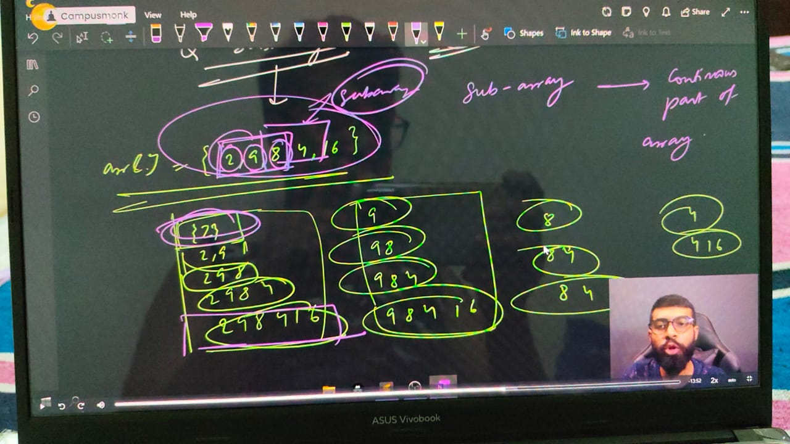

**// Qun - If target found using subarray sum then put yes otherwise leave it with no.**

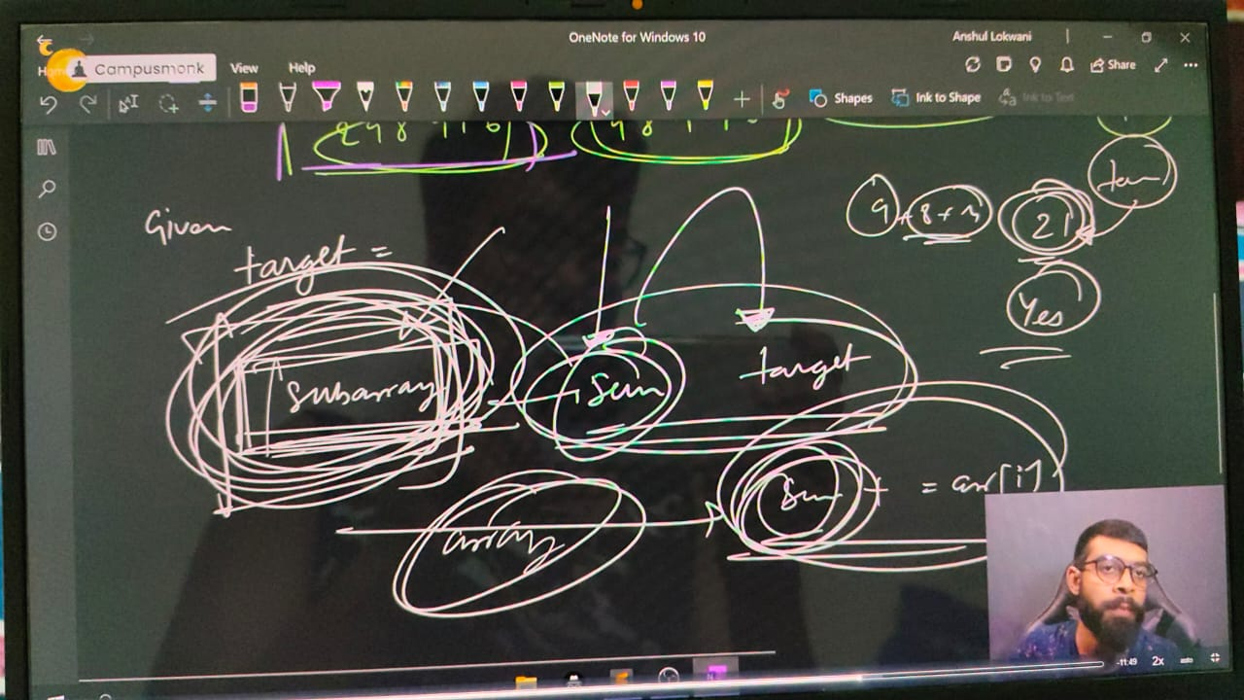

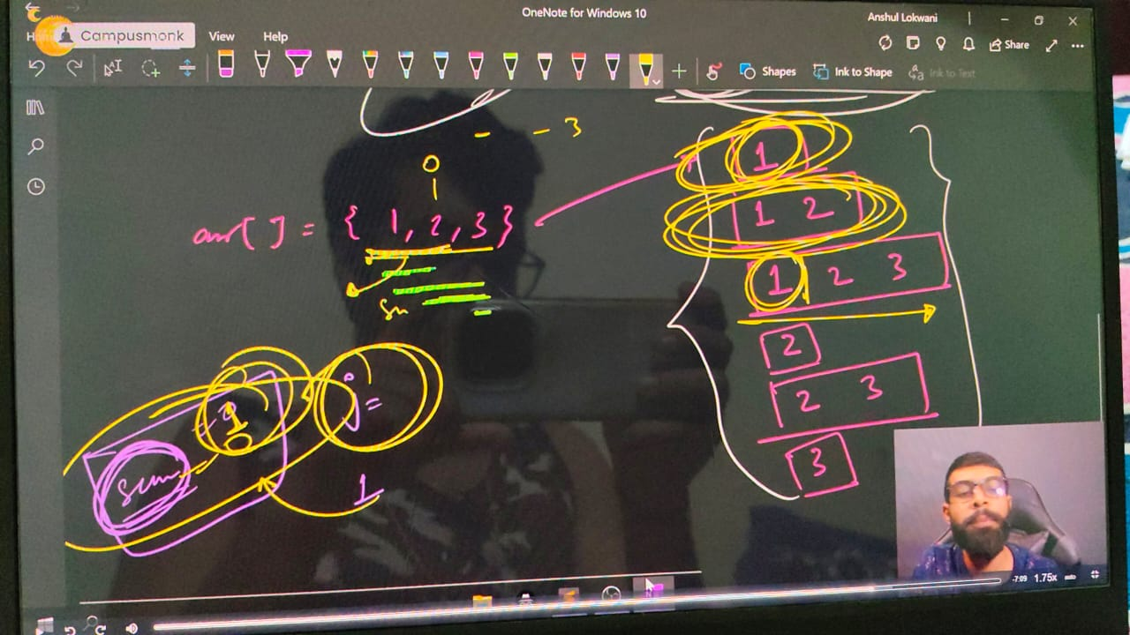

    int n;

    cout<<"Array Size"<<endl;

    cin>>n;

    int arr[n];

    cout<<"Array Elements - "<<endl;

    for (int i = 0; i < n; i++)

    {

        cin>>arr[i];

    }

    cout<<"So, your entered array is - "<<endl;

    for (int i = 0; i < n; i++)

    {

        cout<<arr[i]<<" ";

    }

    cout<<endl;

    int target;

    cout<<"Now press thye Target ELement - "<<endl;

    cin>>target;

    // For subarray sum -

    for (int i = 0; i < n; i++)

    {

        int sum=0;

        for (int j = i; j < n; j++)

        {

            sum+=arr[j];

            if (sum==target)

        {

            cout<<"Yes by using subsrray sum we got the target sum"<<endl;

            return 0;

        }

        }

    }

    cout<<"Not found"<<endl;

/*

Array Size

5

Array Elements -

1 2 3 4 5

So, your entered array is -

1 2 3 4 5

Now press thye Target ELement -

9

Yes by using subsrray sum we got the target

7

Yes by using subsrray sum we got the target sum

8

Not found

*/

___________ ____________ ____________ ____________ ____________ ____________ ____________ ____________

**// Qun - 11) - maximum Profit on selling  -**

**// Note - It's mandatory to first buy then sell the share**

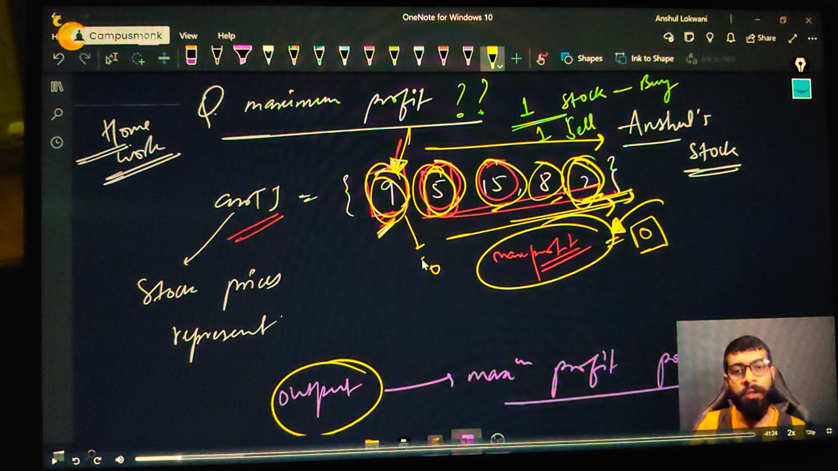

    int n;

    cout << "Mention the array size" << endl;

    cin >> n;

    int arr5[n];

    cout << "Put Market Prices of Shares " << endl;

    for (int i = 0; i < n; i++)

    {

        cin >> arr5[i];

    }

    cout << "So, the stock prixes inside the araay is - " << endl;

    for (int i = 0; i < n; i++)

    {

        cout << arr5[i]<<" ";

    }

    cout<<endl;

    int max_profit = 0;

    for (int i = 0; i < n; i++)

    {

        int buying_price = arr5[i];

        for (int j = i; j < n; j++)

        {

            int selling_price = arr5[j];

            if (selling_price - buying_price > max_profit)

            {

                max_profit = selling_price - buying_price;

            }    // or coudl be done by using max funciton - max_profit = max(max_profit, arr[j]-arr[i])

        }

    }

    cout << "So, the profile as per the buying and selling price is - " << max_profit << endl;

}

/*

Mention the array size

5

Put Market Prices of Shares

9 5 15 8 2

So, the stock prixes inside the araay is -

9 5 15 8 2

So, the profile as per the buying and selling price is - 10

Mention the array size

5

Put Market Prices of Shares

7 12 15 8 30

So, the stock prixes inside the araay is -

7 12 15 8 30

So, the profile as per the buying and selling price is - 23

*/

// ____________ ____________ ____________ ____________ ____________ ____________ ____________ ____________ ____________ ____________ ____________

**String Programs -**

1 - Taking Input in string, Sort & Reverse, Palindrome of string.

2 - WAP for Count words in string -

2.1 - Program for count Vowels & Consonants in String-

3 - For the 2 given strings check that are they both Anagram of each other. print yes or no only

4 - Program for Sum of numbers inside the string.

5 - make first letter capital of given string or user taken string, but if already capital then no need to change anything -

6 - make first letter Small of given string or user taken string, but if already Small then no need to change anything -

7 - For the entire string convert Upper string to Lower string

8 - change all the cases of string.

9 - Remove Vowels, Consonants from the given string.

10 - Distinguish Vowels and Consonants in a given string -

11 - common letters sequences in a string -

12 - For given two strings check that are rotation of each other or not?

13 - Enter the First Non-Repeating Character from the given string -

14 - Find the First Repeating element of the string -

**Strings in CPP** –

#include <bits/stdc++.h>

// #include <iostream>

// #include<algorithm>

// #include<climits>

// #include<string>

// #include<cctype>

using namespace std;

int main()

{

**// Character Array or Strings -**

    char arr[7] = {'S', 'H', 'U', 'b', 'H', 'A', 'm'};

    for (int i = 0; i < 7; i++)

    {

        cout << arr[i] << " ";

    }

    // Note - Every character array or string contains a null character

    // Character array or string can print all elements at a time no need to print one by one as int array

    cout << "i'm in Microsoft " << endl;

    cout << arr[7];

    cout << " 51LPA Package" << endl;

    // i'm in Microsoft Ç 51LPA Package ; -  b/w both the strings, here ia a null character

    // It is basiocally '\0'

    // ____________ ____________

    /*

**String Basic Syntax - data_type variable name : - string s1**

    In string value is given by double quotes, while for the single variable it is given by single quotyes

    String is a contiguos char array.

    In string no need to give size manualy as char array. It is dynamic and allot the size automatically

    */

**// Taking input in string -** If there is no space then use cin>> for input but for the sentence or line with multiple words by using getline funciton

    // string s1 = "";

    // cout<<"Now give the string value - "<<endl;

    // cin>>s1;// he, buddy what's1 app, i got placed in Microsoft

    // cout<<s1<<endl;//he,

    // getline(cin,s1);

    // cout<<s1<<endl;//he, buddy what's1 app, i got placed in Microsoft

    // ____________ ____________

**// Now for printing the string using for loop concept  -** as we know evry string having null character at last

    // string s1;

    // getline(cin,s1);//Congratulations, Shubham..!! for getting placed in Microsoft

    // cout<<s1<<endl;//Congratulations, Shubham..!! for getting placed in Microsoft

    // for (int i = 0; s1[i] == '\0' ; i++)

    // {

    // cout<<s1[i]<<" ";

    // }

    // // C o n g r a t u l a t i o n s1 ,   S h u b h a m . . ! !   f o r   g e t t i n g   p l a c e d   i n   M i c r o s1 o f t

    // // For printing how many characters total in the string using for loop.

    // for (int i = 0; s1[i] == '\0' ; i++)

    // {

    // cout<<i;

    // }

    // 01234567891011121314151617181920212223242526272829303132333435363738394041424344454647484950515253545556575859

    // ____________ ____________

**// check that in entered string there is space or not ?, so using for loop**

    // string s2;

    // cout<<"what is your statement dude ..!!"<<endl;//Microsft Hyderabad,MicrosoftHyderabad

    // getline(cin, s2);

    // cout<<"So you informed about - "<<s2<<endl;//Microsft Hyderabad

    // cout<<s2.size();// 19

    // for (int i = 0; s2[i] == '\0'; i++)

    // {

    //     if (s2[i] == ' ')

    //     {

    //         cout<<"Yes Space Exist";

    //         return 0;

    //     }

    // }

    // cout<<"No space buddy";

    // ____________ ____________

**// Sort & reverse for the string array -**

    // string s1;

    // cout<<"What's1 in your mind"<<endl;

    // cin>>s1;//MicrosoftBengaluru

**// // sort function for string -**

    // sort(s1.begin(), s1.end());

    // cout<<s1<<endl;//BMacefgilnoorrstuu

**// // reverse function for string -**

    // reverse(s1.begin(), s1.end());

    // cout<<s1<<endl;//urulagneBtfosorciM

    // ____________ ____________

**// Palindrome string -**

    // string s1;

    // cout<<"What's1 in your mind"<<endl;

    // getline(cin,s1);

    // string original = s1;

    // reverse(s1.begin(), s1.end());

    // if (original == s1)

    // {

    //     cout<<"Yes, Palindrome";

    // }

    // else

    // {

    //     cout<<"Not a palindrome string";

    // }

    /*

    naman

    Yes, Palindrome

    */

// ____________ ____________ ____________ ____________ ____________

**// Qun1 -  Count words in string -**

    // string s1;

    // cout<<"What's1 in your mind"<<endl;

    // getline(cin,s1);

    // int space=0;

    // for (int i = 0; s1[i] == '\0'; i++) // OR for(int i=0; i<s1.size(); i++)

    // {

    //     if (s1[i] == ' ')

    //     {

    //         space++;

    //     }

    // }

    // cout<<"the no. of spaces here is - "<<space<<endl;

    // int words = space+1;

    // cout<<"So total words is -  "<<words<<endl;

    /*

    What's1 in your mind

    Thank You, I accept the offer from Microsoft for hyderabad Location.

    the no. of spaces here is - 10

    So total words is -  11

    */

    // using functions -

    // #include <bits/stdc++.h>

    // using namespace std;

    // int count_words(string s1)

    // {

    //     int space = 0;

    //     for (int i = 0; i < s1.size(); i++) // OR for(int i=0; s1[i] == '\0'; i++)

    //     {

    //         if (s1[i] == ' ')

    //         {

    //             space++;

    //         }

    //     }

    //     return space + 1;

    // }

    // int main()

    // {

    //     string s1;

    //     cout << "What's1 in your mind" << endl;

    //     getline(cin, s1);

    //     cout << count_words(s1);

    // }

// ____________ ____________

**// Qun 2 -  Count words in string -**

**// For Vowels using function -**

    // #include <bits/stdc++.h>

    // using namespace std;

    // int count_vowels(string s1)

    // {

    //     int count = 0;

    //     for (int i = 0; i < s1.size(); i++) // OR for(int i=0; s1[i] == '\0'; i++)

    //     {

    //         if (s1[i] == 'a' ||s1[i] == 'e' ||s1[i] == 'i' ||s1[i] == 'o' ||s1[i] == 'u' || s1[i] == 'A' ||s1[i] == 'E' ||s1[i] == 'I' ||s1[i] == 'O' ||s1[i] == 'U')

    //         {

    //             count++;

    //         }

    //     }

    //     return count;

    // }

    // int main()

    // {

    //     string s1;

    //     cout << "What's1 in your mind" << endl;

    //     getline(cin, s1);

    //     cout << count_vowels(s1);

    // }

// ____________ ____________

**// Qun 2.1 -  Count Consonants in string -**

**// For Consonants using function -**

    // #include <bits/stdc++.h>

    // using namespace std;

    // int count_Consonants(string s1)

    // {

    //     int count = 0;

    //     for (int i = 0; i < s1.size(); i++) // OR for(int i=0; s1[i] == '\0'; i++)

    //     {

    //         if (!(s1[i] == 'a' ||s1[i] == 'e' ||s1[i] == 'i' ||s1[i] == 'o' ||s1[i] == 'u' || s1[i] == 'A' ||s1[i] == 'E' ||s1[i] == 'I' ||s1[i] == 'O' ||s1[i] == 'U'))

    //         {

    //             count++;

    //         }

    //     }

    //     return count;

    // }

    // int main()

    // {

    //     string s1;

    //     cout << "What's1 in your mind" << endl;//Microsoft Hyderabad

    //     getline(cin, s1);

    //     cout << count_Consonants(s1);// 13

    // }

// ____________ ____________ ____________ ____________ ____________

**// QUn 3 - For the 2 given strings check that are they both Anagram of each other. print yes or no only**

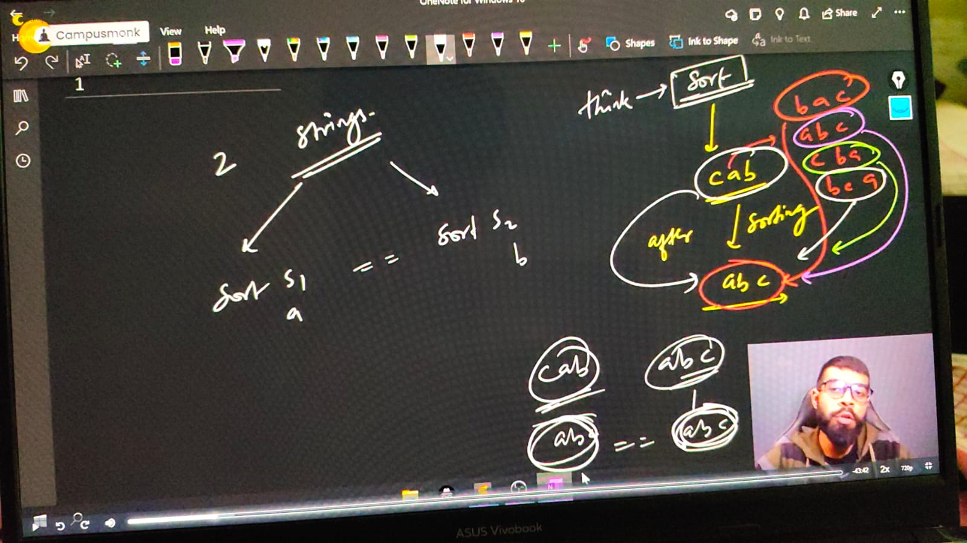

    /*

    Anagram - ek string ke saare characters kisi bhi order me utne hi no. of times agr dusri string me aa rhe he, and no ay another character, then they are Anagram of each other.

    Ex. - S1 - abc, and S2 - cba or bac or bca any of these are Ahanagram of String -1

    */

    // string s1,s2;

    // cout << "What's1 in your mind" << endl;//Microsoft Hyderabad

    // cout<<"Enter the first string   - "<<" ";

    // getline(cin, s1);

    // cout<<"Now, Enter the Second string   - "<<" ";

    // getline(cin, s2);

    // sort(s1.begin(), s1.end());

    // sort(s2.begin(), s2.end());

    // cout<<"After sort string 1 is "<<s1<<" and string 2 is "<<s2<<endl;

    // if (s1==s2)

    // {

    //     cout<<"So clearly, strings are Anagram";

    // }

    // else

    // {

    //     cout<<"we can see, strings are Not an Anagram";

    // }

    /*

    What's1 in your mind

    Enter the first string   -  shruti

    Now, Enter the Second string   -  rutish

    After sort string 1 is hirstu and string 2 is hirstu

    So clearly, strings are Anagram

    What's1 in your mind

    Enter the first string   -  Madhuri

    Now, Enter the Second string   -  ridhima

    After sort string 1 is Madhiru and string 2 is adhiimr

    we can see, strings are Not an Anagram

    What's1 in your mind

    Enter the first string   -  Muskan

    Now, Enter the Second string   -  upmuskan

    After sort string 1 is Maknsu and string 2 is akmnpsuu

    we can see, strings are Not an Anagram

    */

// ____________ ____________ ____________ ____________ ____________

**// Qun 4 - Sum of numbers inside the string.**

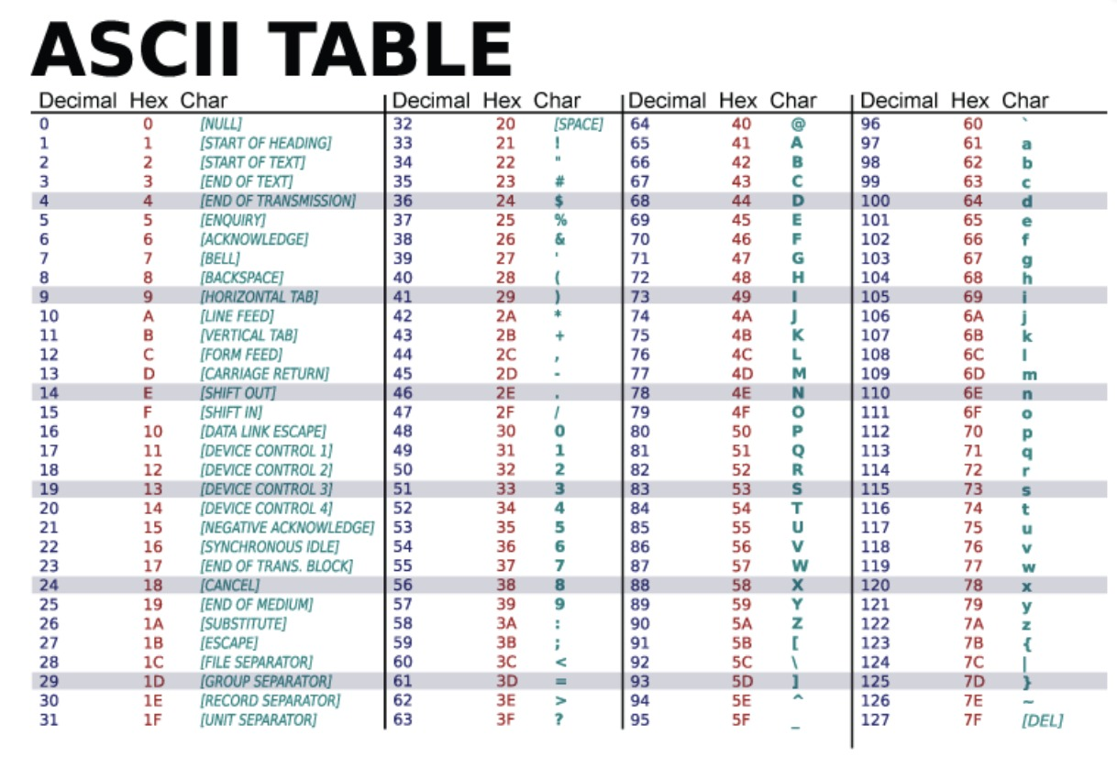

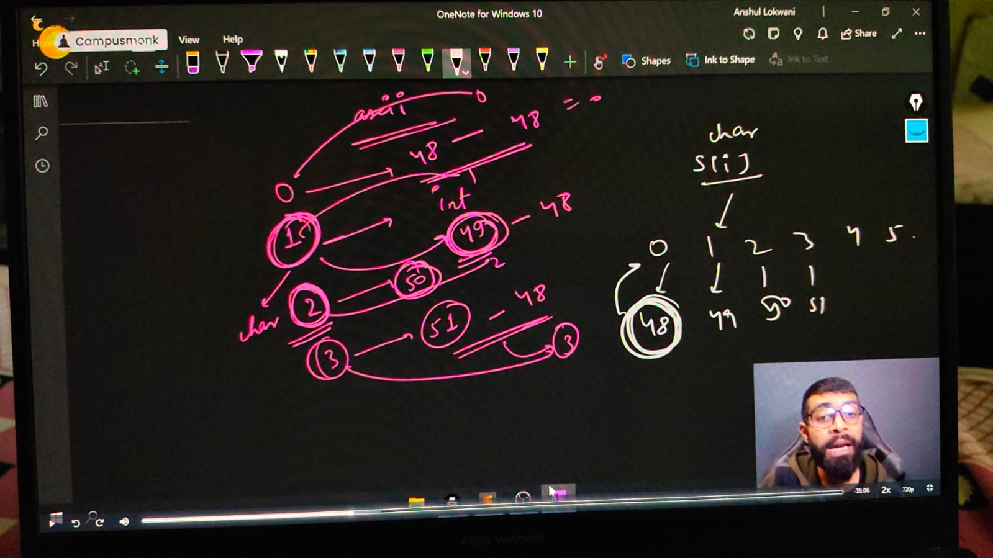

    // string s1 = "1578";

    // // Sum of int in a string

    // int sum=0;

    // for (int i = 0; i <s1.size(); i++)

    // {

    //     // sum+=s1[i];

    //     sum+=s1[i]-'0'; // OR

    //     // sum+=s1[i]-48;

    // }

    // cout<<"So, the sum of int inside string is - "<<sum<<endl;

    // So, the sum of int inside string is - 213 - which is wrong because in string int deals with Ascii value as its a character in a string. So its giving the sum of ASCII values of ths entered integers

    // So, for overoming this int problem in string we need to substract 45 which is ASCII value of

    /*

    So, the sum of int inside string is - 21

    */

    // ____________ ____________ ____________ ____________ ____________

**// Capital & SMall characters OR Lower & Upper case in String -**

    // string a = "abc";

    // string b = "ABC";

    // if (a==b)

    // {

    //     cout<<"Yes"<<endl;

    // }

    // // So cleaarly it isn't printing anything as both are different because of Ascii values.

    // cout<<int('A')<<endl;//65

    // cout<<int('Z')<<endl;//90

    // cout<<int('a')<<endl;//97

    // cout<<int('z')<<endl;//122

    // cout<<int('0')<<endl;//48

    // cout<<int('9')<<endl;//57

    // ____________ ____________

**// Lower & Upper case -**

**// Qun 5 -  make first letter capital of given string or user taken string, but if already capital then no need to change anything -**

    // string a = "shruti";

    // 📌 Logic - For making first letter capital of given small case string , simple substract the no. 32 which is ASCII Value difference of a-A : 97-65 = 32. and applicable for all the alphabets

    // a[0]-=32;

    // cout<<a<<endl;//Shruti.

    // string a1;

    // cout<<"What word you want to write and conver the first lower letter into upper letter"<<endl;

    // getline(cin, a1);

    // // cout<<"So the changes is here -  "<<a1<<endl;//So the changes is here -  Google

    // // but what if I alreaady write first letter capital in the string with this logic. then we get any another result, so the condition for avoiding that is -

    // if (a1[0]>='a'&& a1[0]<='z')

    // {

    // a1[0]-=32;

    // }

    // cout<<"So the changes is here -  "<<a1<<endl;

// ____________ ____________

**// Qun 6 -  make first letter Small of given string or user taken string, but if already Small then no need to change anything -**

    // string a1;

    // cout<<"What word you want to write and conver the first lower letter into lowewr letter"<<endl;

    // getline(cin, a1);//Google

    // if (a1[0]>='A'&& a1[0]<='Z')

    // {

    //     a1[0]+=32;

    // }

    // cout<<"So the changes is here -  "<<a1<<endl;//So the changes is here -  google

    // ____________ ____________

**// // Qun - For the entirre string convert small string to capital string**

    //     string a1;

    //     cout<<"What's1 in your mind for upper letter converison"<<endl;

    //     getline(cin, a1);

    //     for (int i = 0; i < a1.size(); i++)//google

    //     {

    //         if (a1[i]>='a' && a1[i]<='z')

    //         {

    //             a1[i]-=32;

    //         }

    //     }

    //     cout<<"So, string we got in Upper Case is "<<a1<<endl;//GOOGLE

    /*

    What word you want to write and conver the first lower letter into lowewr letter

    microsoft

    So, string we got in Upper Case is MICROSOFT

    What word you want to write and conver the first lower letter into lowewr letter

    MicroSoft

    So, string we got in Upper Case is MICROSOFT

    */

// ____________ ____________

**// Qun 7 - For the entirre string convert Upper string to Lower string**

    // string a1;

    // cout<<"What's1 in yor mind for lower letter strig - "<<endl;

    // getline(cin, a1);

    // for (int i = 0; i < a1.size(); i++)//google

    // {

    //     if (a1[i]>='A' && a1[i]<='Z')

    //     {

    //         a1[i]+=32;

    //     }

    // }

    // cout<<"So, string we got in Upper Case is "<<a1<<endl;//GOOGLE

    /*

    What's1 in yor mind for lower letter strig -

    ATLASSIAN

    So, string we got in Upper Case is atlassian

    What's1 in yor mind for lower letter strig -

    AtlassIan

    So, string we got in Upper Case is atlassian

    */

    // ____________ ____________

    // Upper to Lower using shortcuts -

    // string s1 = "Microsoft";

    // // s1[0]= tolower(s1[0]);

    // cout<<s1<<endl; // microsoft

    // s1[3]= toupper(s1[3]);

    // cout<<s1<<endl;//MicRosoft

// ____________ ____________

**// Qun 8 - change all the cases of string.**

    //     string s1 = "sHubhAm";

    //     for (int i = 0; i < s1.size(); i++)

    //     {

    //         if (s1[i]>='a' && s1[i]<='z')

    //         {

    //             s1[i]-=32;

    //         }

    //         else if (s1[i]>='A' && s1[i]<='Z')

    //         {

    //             s1[i]+=32;

    //         }

    //         else

    //         {

    //             cout<<"This is not an alphabetical character here"<<endl;

    //         }

    //     }

    //     cout<<"So, after the case changes the string we have is - "<<s1<<endl;//So, after the case changes the string we have is - ShUBHaM

    //     // Now by taking user input manualy -

    //     string s2;

    //     cout<<"What's in your minf Babes ..!!"<<endl;

    //     getline(cin, s2);

    //     for (int i = 0; i < s2.size(); i++)

    //     {

    //         if (s2[i]>='a' && s2[i]<='z')

    //         {

    //             s2[i]-=32;

    //         }

    //         else if (s2[i]>='A' && s2[i]<='Z')

    //         {

    //             s2[i]+=32;

    //         }

    //         else

    //         {

    //             cout<<"This is not an alphabetical character here"<<endl;

    //         }

    //     }

    //     cout<<"So, after the case changes the string we have is - "<<s2<<endl;

    /*

    So, after the case changes the string we have is - ShUBHaM

    What's in your minf Babes ..!!

    nAmAn

    So, after the case changes the string we have is - NaMaN

    */

// ____________ ____________

**//  String another operations -**

**// String additioon -**

    string a = "Microsoft ", b = "Hyderabad";

    string c = a + " " + b;

    cout << c << endl; // Microsoft Hyderabad

    // w/o using any 3rd string

    a += b;

    cout << a << endl; /// Microsoft Hyderabad

**// Qun 9 - Remove Vowels, COnsonants from the given string.**

**// Remove vowels from string -**

    // string s = "Microsoft";

    // for (int i = 0; i < s.size(); i++)

    // {

    //     if (!(s[i] == 'a' ||s[i] == 'e' ||s[i] == 'i' ||s[i] == 'o' ||s[i] == 'u' || s[i] == 'A' ||s[i] == 'E' ||s[i] == 'I' ||s[i] == 'O' ||s[i] == 'U'))

    //     {

    //         cout<<s[i];

    //     }

    // }

    // o/p -  Mcrsft

    // ____________ ____________

**// Remove Consonants from string -**

    // string s = "Microsoft";

    // for (int i = 0; i < s.size(); i++)

    // {

    //     if ((s[i] == 'a' ||s[i] == 'e' ||s[i] == 'i' ||s[i] == 'o' ||s[i] == 'u' || s[i] == 'A' ||s[i] == 'E' ||s[i] == 'I' ||s[i] == 'O' ||s[i] == 'U'))

    //     {

    //         cout<<s[i];

    //     }

    // }

    // o/p - ioo

// ____________ ____________ ____________ ____________ ____________

**//Qun 10 - Distinguish Vowels and Consonants in a given string -**

    // string s;

    // cout << "Buddy, what are you thinking about " << endl;

    // getline(cin, s);

    // string vwls, cnsnnts, NoALphaChar;

    // for (int i = 0; i < s.size(); i++)

    // {

    //     if ((s[i] >= 'a' && s[i] <= 'z') || (s[i] >= 'A' && s[i] <= 'Z') || s[i]==' ')

    //     {

    //         if (s[i] == 'a' || s[i] == 'e' || s[i] == 'i' || s[i] == 'o' || s[i] == 'u' ||

    //             s[i] == 'A' || s[i] == 'E' || s[i] == 'I' || s[i] == 'O' || s[i] == 'U')

    //         {

    //             vwls += s[i];

    //         }

    //         else

    //         {

    //             cnsnnts += s[i];

    //         }

    //     }

    //     else

    //     {

    //         NoALphaChar+=s[i];

    //     }

    // }

    // cout << "So, all voweks of givenstring is - " << vwls << endl;

    // cout << "So, all consonants of givenstring is - " << cnsnnts << endl;

    // cout << "It's not an alphabetical character: " << NoALphaChar << endl;

    /*

    Buddy, what are you thinking about

    Shubham Mahajan 880

    So, all voweks of givenstring is - uaaaa

    So, all consonants of givenstring is - Shbhm Mhjn

    It's not an alphabetical character: 880

    */

// ____________ ____________ ____________ ____________ ____________

**// Qun 11 - common letters sequences in a string -**

**// Using shortcut menthod of STL -**

    // string text,pattern;

    // cin>>text>>pattern;

    // size_t index = text.find(pattern,5);

    // if (index!=string::npos)

    // {

    //     cout<<index<<endl;

    // }

    /*

    abcdefabcghijabc

    abc

    6

    */

// ____________ ____________ ____________ ____________ ____________

**//Qun 12 - For given two strings check that are rotation of each other or not?**

    // string two,one;

    // cout<<"write string one and two respectively "<<endl;

    // cin>>one>>two;

    // /*

    // Rotation concept - Campus - 1st :-scampu, 2nd:-uscamp, 3rd:-puscam, 4th:-mpusca, 5th:-ampusc, 6th :=campus

    // 📌 Logic - if we write twuce a string then it can create all possible rotation of itself.

    // */

    // string check = one+one;

    // auto index = check.find(two);//using find function

    // if (index != string::npos)//STL Vector Part

    // {

    //     cout<<"Yes, they are rotation  of each other";

    // }

    // else

    // {

    //     cout<<"No, they are not";

    // }

    /*

    write string one and two respectively

    abc

    bac

    No, they are not

    write string one and two respectively

    abc

    bca

    Yes, they are rotation  of each other

    */

// ____________ ____________ ____________ ____________ ____________

**//Qun 13 - Enter the First Non-Repeating Character from the given string -**

//     string s3;

//     cout << "WHat's the text wants to share" << endl;

//     cin >> s3;

//     for (int i = 0; i < s3.size(); i++)

//     {

//         bool  repeating = false;

//         for (int j = 0; j < s3.size(); j++)

//         {

//             if (j!=i)// jis pr khade h usko check nhi krna h, otherwise matlb hi kya non repeatinhg check krne ka

//             {

//                 if (s3[j]==s3[i])

//                 {

//                     repeating = true;

//                     break; // agr ek baar repeating hua to agge bhui hoga hi              }

//             }

//         }

//     }

//     if (repeating == false)

//     {

//         cout<<s3[i]<<endl;

//         return 0;

//     }

// }

// cout<<"Not Found"<<endl;

/*

WHat's the text wants to share

abdbcdaeghh

c

WHat's the text wants to share

naman

m

*/

// ____________ ____________

**//Qun 14- Find the First Repeating element of the string -**

// string s3;

// cout << "WHat's the text wants to share" << endl;

// cin >> s3;

// for (int i = 0; i < s3.size(); i++)

// {

//     for (int j = 0; j < s3.size(); j++)

//     {

//         if (j!=i)

//         {

//             if (s3[j]==s3[i])

//             {

//                 cout<<"First Repeating String is - "<<s3[i];

//                 return 0;

//             }

//         }

//     }

// }

/*

WHat's the text wants to share

zxanfgung

First Repeating String is - n

WHat's the text wants to share

naman

First Repeating String is - n

WHat's the text wants to share

shubham

First Repeating String is - h

*/

**// Method - 2**

// string s4;

// cout << "WHat's the text wants to share" << endl;

// cin >> s4;

// for (int i = 0; i < s4.size(); i++)

// {

//     int count=0;

//     for (int j = 0; j < s4.size(); j++)

//     {

//         if (s4[j]==s4[i])

//         {

//             count++;

//         }

//     }

//     if (count>1)

//     {

//         cout<<"First Repeated character is - "<<s4[i]<<"  and repeated - "<<count<<" times"<<endl;

//         return 0;

//     }

// }

// cout<<"Not found the repeated character"<<endl;

/*

WHat's the text wants to share

shubham

First Repeated character is - h  and repeated - 2 times

WHat's the text wants to share

naman

First Repeated character is - n  and repeated - 2 times

WHat's the text wants to share

indrajeet

First Repeated character is - e  and repeated - 2 times

WHat's the text wants to share

Mahajan

First Repeated character is - a  and repeated - 3 times

WHat's the text wants to share

Pradhyumn

Not found the repeated character

*/

}

**Matrix OR 2D Array in CPP –**

Matrix/2-D Array Programs -

1 - Basic Input/Output of 2D Array.

2 - Print Sum of all elements in the matrix -

3 - check for the target element that it is present in the matrix or not, if present then print Yes.

4 - Find the absolute difference of both diagonal elements of a Matrix

5 - Find the sum of only boundary elements in the matrix -

6 - Transpose of a Matrix -

7 - Rotate the Matrix by 180 degrees.

8 - Rotate the array by 90 CLW.

9 - Rotate the array by 90 ACLW.

**Matrix OR 2D Array in CPP –**

#include <bits/stdc++.h>

// #include <iostream>

// #include<algorithm>

// #include<climits>

// #include<string>

// #include<cctype>

using namespace std;

int main()

{

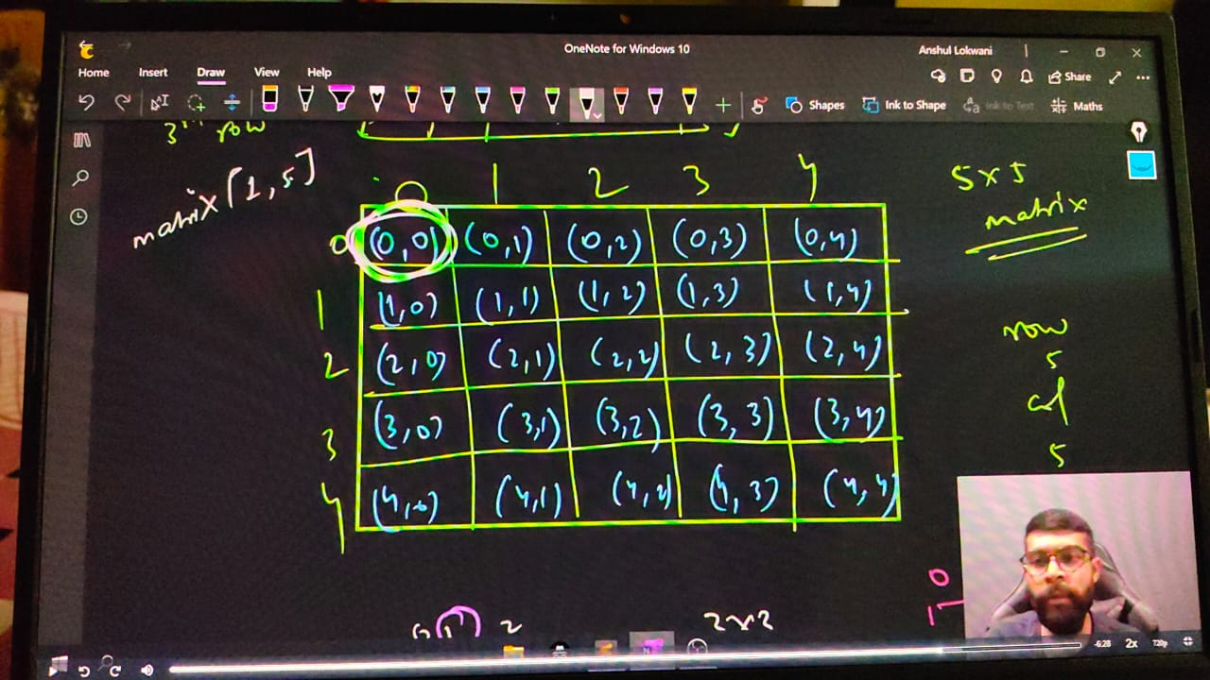

  /*

**initialize a 2D Array -**

**Standard Syntax -**

    DATATYPE Name ARRAYNAME[No.of Row][No.ofColumn];

    */

    // int matrix[5][5];

    // matrix[1][2] = 10;

    // cout << matrix[1][2]; // 10

    // cout << endl;

    //    taking input manally for a single value

    // cin>>matrix[1][2];//75

    // cout<<matrix[1][2];//75

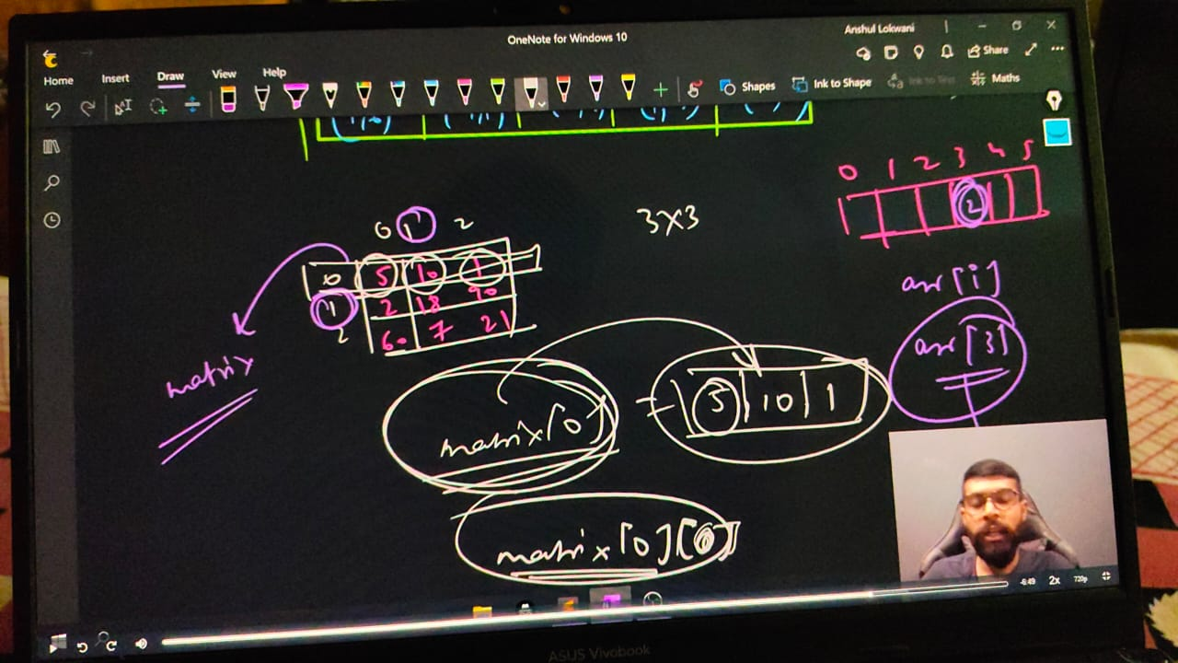

**// taking inputs for all the values of matrix -**

    // int n,m;

    // cout<<"Enter the no. of rows and columns respectively"<<endl;

    // cin>>n>>m;

    // int matrix2[n][m];

    // cout<<"Now, enter the elements value"<<endl;

    // for (int i = 0; i < n; i++)

    // {

    //     for (int j = 0; j < m; j++)

    //     {

    //         cin>>matrix2[i][j];

    //     }

    // }

**// // Printing the entered matrix -**

    // for (int i = 0; i < n; i++)

    // {

    //     for (int j = 0; j < m; j++)

    //     {

    //         cout<<matrix2[i][j]<<" ";

    //     }

    //     cout<<endl;

    // }

    /*

    Enter the no. of rows and columns respectively

    3 3

    Now, enter the elements value

    1 2 3 4 5 6 7 8 9

    1 2 3

    4 5 6

    7 8 9

    */

**// ____________ ____________ ____________ ____________ ____________**

**// Qun2 - Print SUm of all elements in the matrix -**

    // int n,m;

    // cout<<"Enter the no. of rows and columns respectively"<<endl;

    // cin>>n>>m;

    // int matrix2[n][m];

    // // taking input from user

    // cout<<"Now, enter the elements value"<<endl;

    // for (int i = 0; i < n; i++)

    // {

    //     for (int j = 0; j < m; j++)

    //     {

    //         cin>>matrix2[i][j];

    //     }

    // }

    // // Printing the entered matrix -

    // for (int i = 0; i < n; i++)

    // {

    //     for (int j = 0; j < m; j++)

    //     {

    //         cout<<matrix2[i][j]<<" ";

    //     }

    //     cout<<endl;

    // }

    //     int sum=0;

    // // Printing the sum of entered matrix -

    // for (int i = 0; i < n; i++)

    // {

    //     for (int j = 0; j < m; j++)

    //     {

    //         sum+=matrix2[i][j];

    //     }

    // }

    // cout<<"So, the sum of entire matrix is - "<<sum<<endl;

    /*

Enter the no. of rows and columns respectively

3 3

Now, enter the elements value

1 2 3 4 5 6 7 8 9

1 2 3

4 5 6

7 8 9

So, the sum of entire matrix is - 45

    */

// ____________ ____________ ____________ ____________ ____________

**// QUn 3 -check for the target element that it is present in the matrix or not, if present then print Yes.**

    // int n, m;

    // cout << "Enter the no. of rows and columns respectively" << endl;

    // cin >> n >> m;

    // int matrix2[n][m];

    // // taking input from user

    // cout << "Now, enter the elements value" << endl;

    // for (int i = 0; i < n; i++)

    // {

    //     for (int j = 0; j < m; j++)

    //     {

    //         cin >> matrix2[i][j];

    //     }

    // }

    // // Printing the entered matrix -

    // for (int i = 0; i < n; i++)

    // {

    //     for (int j = 0; j < m; j++)

    //     {

    //         cout<<matrix2[i][j]<<" ";

    //     }

    //     cout<<endl;

    // }

    // int target;

    // cout << "So, what's the targeted element - " << endl;

    // cin >> target;

    // // Printing the sum of entered matrix -

    // for (int i = 0; i < n; i++)

    // {

    //     for (int j = 0; j < m; j++)

    //     {

    //         if (matrix2[i][j]==target)

    //         {

    //             cout<<"Yes it's present and the address is: row no-  "<<i<<" & column no-  "<<j<<" having targeted value-  "<<matrix2[i][j];

    //             return 0;

    //         }

    //     }

    // }

    // cout<<"Sorry, Element Not FOund Bruh.."<<endl;

    /*

    Enter the no. of rows and columns respectively

    3 3

    Now, enter the elements value

    1 2 3 4 5 6 7 8 9

    1 2 3

    4 5 6

    7 8 9

    So, what's the targeted element -

    6

    Yes it's present and the address is: row no-  1 & column no-  2 having targeted value-  6

    Enter the no. of rows and columns respectively

    3 3

    Now, enter the elements value

    1 2 3 4 5 6 7 8 9

    1 2 3

    4 5 6

    7 8 9

    So, what's the targeted element -

    15

    */

// ____________ ____________ ____________ ____________ ____________

**// QUn 4 - Find the absolute difference of both diagonal elemenmts of a Matrix -**

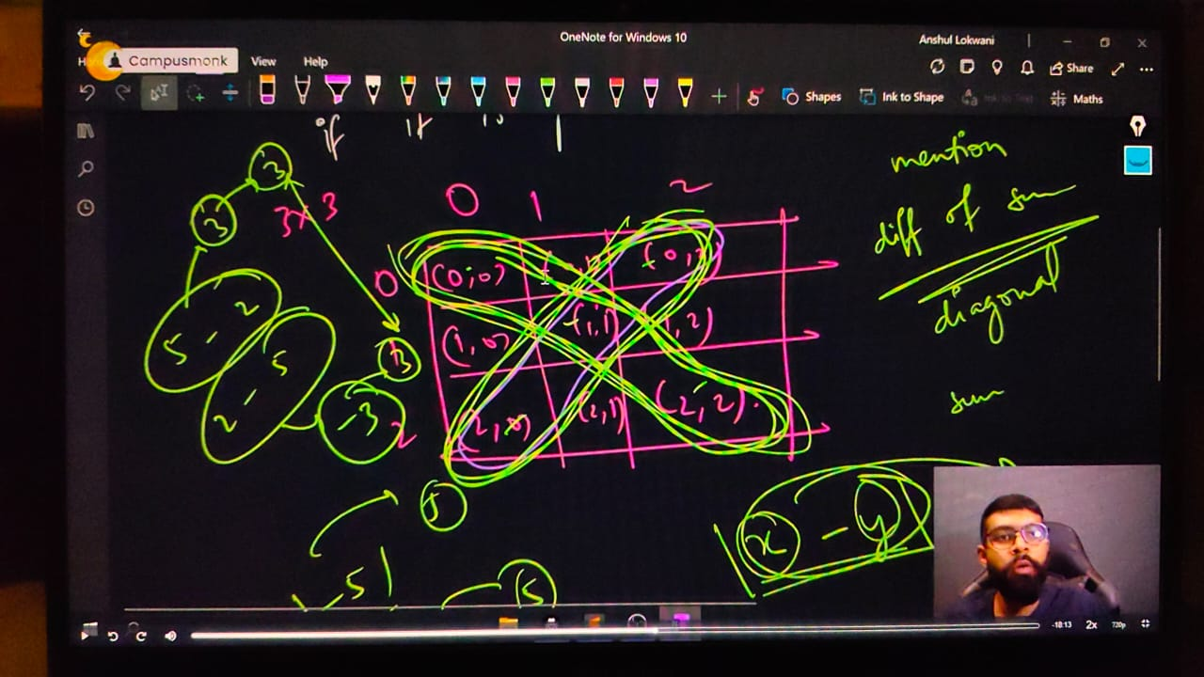

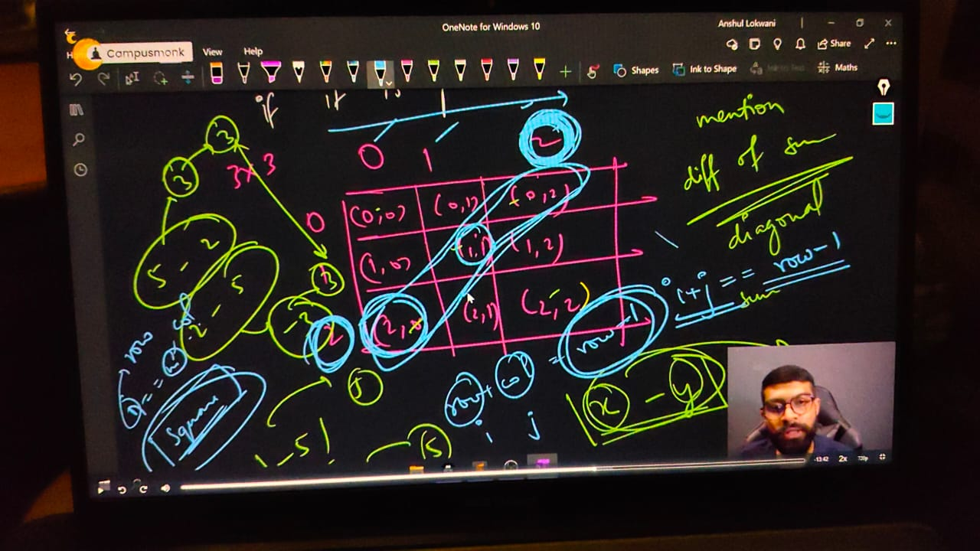

    // int rows, colms;

    // cout << "Enter the roes and column va;ues resprectively" << endl;

    // cin >> rows >> colms;

    // int matrix[rows][colms];

    // cout << "Enter the elements of matrix - " << endl;

    // for (int i = 0; i < rows; i++)

    // {

    //     for (int j = 0; j < colms; j++)

    //     {

    //         cin >> matrix[i][j];

    //     }

    // }

    // cout << "So, youe entered matrix is - " << endl;

    // for (int i = 0; i < rows; i++)

    // {

    //     for (int j = 0; j < colms; j++)

    //     {

    //         cout << matrix[i][j] << " ";

    //     }

    //     cout << endl;

    // }

    // int SumofDiagonal1 = 0;

    // int SumofDiagonal2 = 0;

    // // for principle diagonal elements sum - its sum of dialoganl1

    // for (int i = 0; i < rows; i++)

    // {

    //     for (int j = 0; j < colms; j++)

    //     {

    //         if (i == j)

    //         {

    //             SumofDiagonal1 += matrix[i][j];

    //         }

    //         if (i + j == rows - 1)

    //         {

    //             SumofDiagonal2 += matrix[i][j];

    //         }

    //     }

    // }

    // // For another dialognal sum -

    // cout << "So the sum of PDE is - " << SumofDiagonal1 << " and another diagonal is  " << SumofDiagonal2 << endl;

    // cout << "So, clearly the difference of both diagonals is -  " << abs(SumofDiagonal1 - SumofDiagonal2) << endl;

    // For the absolute difference using abs functin

    /*

    Enter the roes and column va;ues resprectively

    3 3

    Enter the elements of matrix -

    1 2 3 4 5 6 7 8 9

    So, youe entered matrix is -

    1 2 3

    4 5 6

    7 8 9

    So the sum of PDE is - 15 and another diagonal is  15

    So, clearly the difference of both diagonals is -  0

    */

// ____________ ____________ ____________ ____________ ____________

**// Qun 5 - Find the sum of only boundary elements in the matrix –**

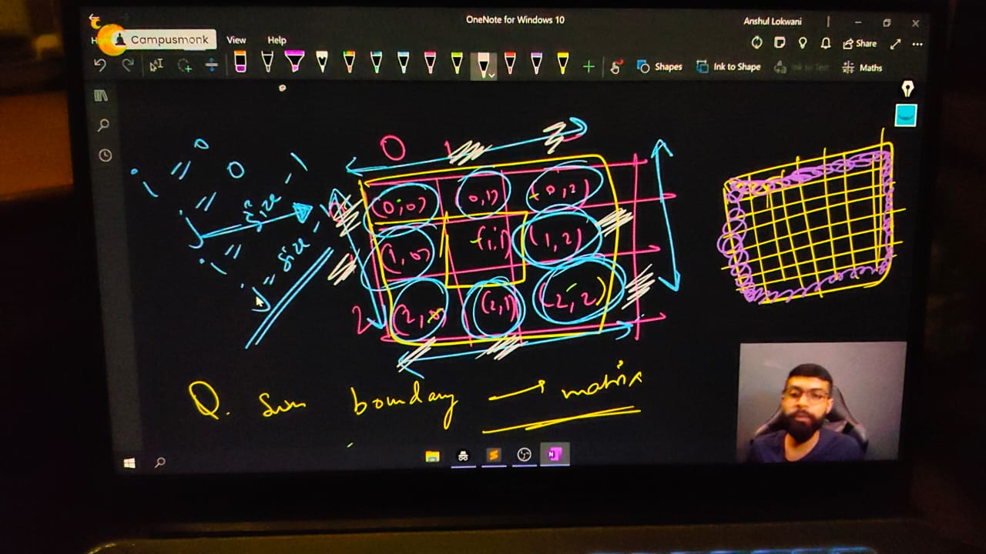

    // int n, m;

    // cout << "Enter the no. of rows and columns respectively" << endl;

    // cin >> n >> m;

    // int matrix2[n][m];

    // // taking input from user

    // cout << "Now, enter the elements value" << endl;

    // for (int i = 0; i < n; i++)

    // {

    //     for (int j = 0; j < m; j++)

    //     {

    //         cin >> matrix2[i][j];

    //     }

    // }

    // // Printing the entered matrix -

    // cout<<"So, your inserted elements in matrix is - "<<endl;

    // for (int i = 0; i < n; i++)

    // {

    //     for (int j = 0; j < m; j++)

    //     {

    //         cout << matrix2[i][j] << " ";

    //     }

    //     cout << endl;

    // }

    // // For Boundry ELemnets Sum -

    // // 📌 Logic - row & colm is max and min which is 0 and n-1,m-1

    // int boundary_sum = 0;

    // for (int i = 0; i < n; i++)

    // {

    //     for (int j = 0; j < m; j++)

    //     {

    //         if (i == 0 || j == 0 || i == n - 1 || j == m - 1)

    //         {

    //             boundary_sum += matrix2[i][j];

    //         }

    //     }

    // }

    // cout<<"So the sum of all boundaries is - "<<boundary_sum<<endl;

    /*

    Enter the no. of rows and columns respectively

    3 3

    Now, enter the elements value

    1 2 3 4 5 6 7 8 9

    1 2 3

    4 5 6

    7 8 9

    So the sum of all boundaries is - 40

    Enter the no. of rows and columns respectively

    3 4

    Now, enter the elements value

    12 5 4 10 7 3 6 9

    1 2 5 3 4 7 6 9 8

    So, your inserted elements in matrix is -

    12 5 4 10

    7 3 6 9

    1 2 5 3

    So the sum of all boundaries is - 58

    */

// ____________ ____________ ____________ ____________ ____________

**// Qun 6 - Transpose of a Matrix –**

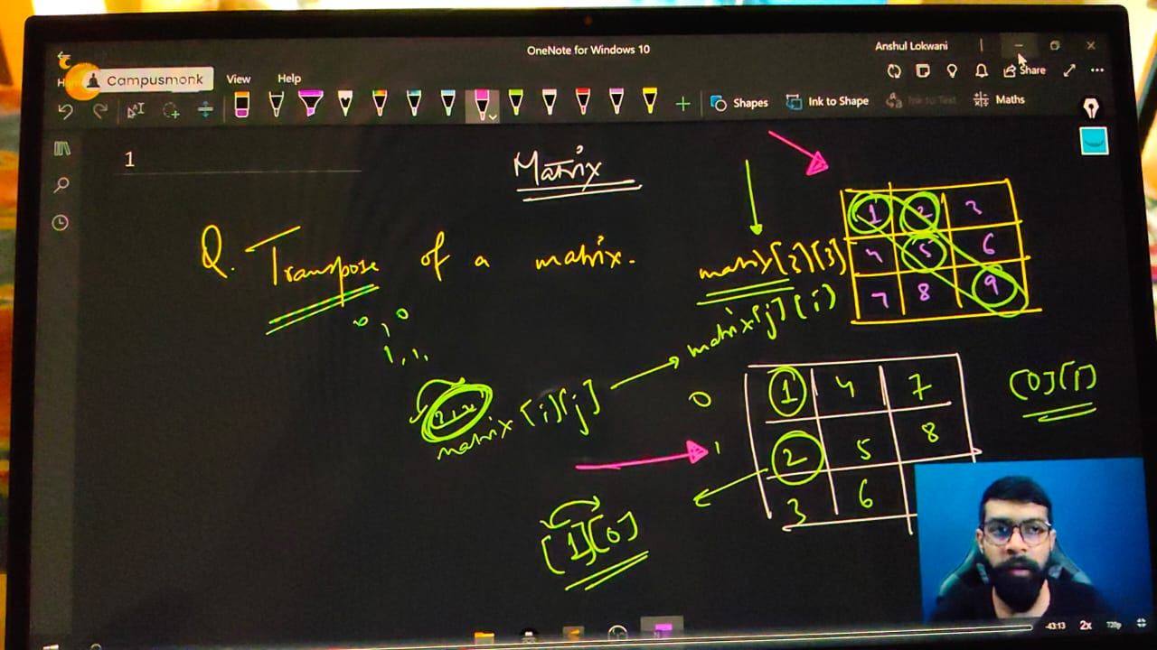

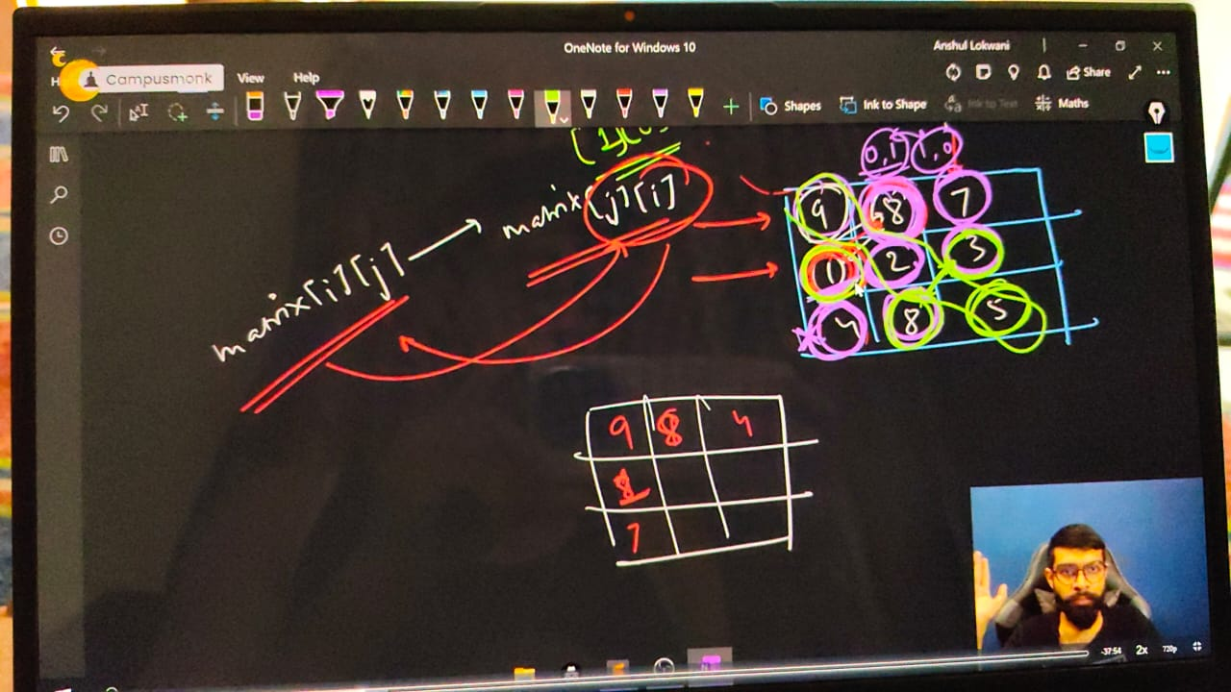

    // int n, m;

    // cout << "ENter the no. of Roews and Columns you want" << endl;

    // cin >> n >> m;

    // int matrix[n][m];

    // cout << "Now insert the matrix elements, mention you favourite Angel numbers " << endl;

    // for (int i = 0; i < n; i++)

    // {

    //     for (int j = 0; j < m; j++)

    //     {

    //         cin >> matrix[i][j];

    //     }

    // }

    // cout<<endl;

    // cout << "So, the entered Array Matrix is - " << endl;

    // for (int i = 0; i < n; i++)

    // {

    //     for (int j = 0; j < m; j++)

    //     {

    //         cout << matrix[i][j] << " ";

    //     }

    //     cout << endl;

    // }

    // cout << endl;

    // For Printing the Transposed Matrices -

    /*

    diagonal ke phle phle hi swap kr rhe h qki uske baad bhi krenge to vapas vvahii matrix aa jayega. That's why used j<i. diagonal ke under under

    Diagonal ke left me - using for (int j = 0; j < i; j++)

    Diagonal ke right me - using for(int j=i; j<n; j++)

    simple diagonal ki ek side ko dusrti side se swap krna he. agr dono side se swap krenge to vapas vahi matrix milega

    */

    // for (int i = 0; i < n; i++)

    // {

    //     for (int j = 0; j < i; j++)

    //     {

    //         swap(matrix[i][j], matrix[j][i]);

    //     }

    // }

    // cout << "And the Transposed Matrices is " << endl;

    // for (int i = 0; i < n; i++)

    // {

    //     for (int j = 0; j < m; j++)

    //     {

    //         cout << matrix[i][j] << " ";

    //     }

    //     cout << endl;

    // }

    /*

    ENter the no. of Roews and Columns you want

    3 3

    Now insert the matrix elements, mention you favourite Angel numbers

    1 2 3 4 5 6 7 8 9

    So, the entered Array Matrix is -

    1 2 3

    4 5 6

    7 8 9

    So, the Transposed Matrices is

    1 4 7

    2 5 8

    3 6 9

    ENter the no. of Roews and Columns you want

    3 3

    Now insert the matrix elements, mention you favourite Angel numbers

    15 10 12 23 56 45 90 87 30

    So, the entered Array Matrix is -

    15 10 12

    23 56 45

    90 87 30

    And the Transposed Matrices is

    15 23 90

    10 56 87

    12 45 30

    */

// ____________ ____________ ____________ ____________ ____________

**// Qun 7 - Rotate the Matrix by 180 degree.**

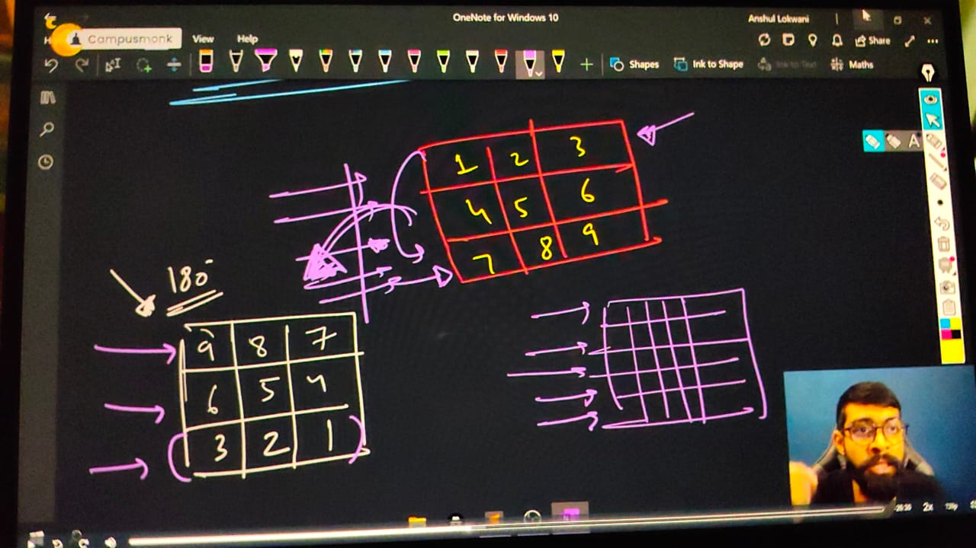

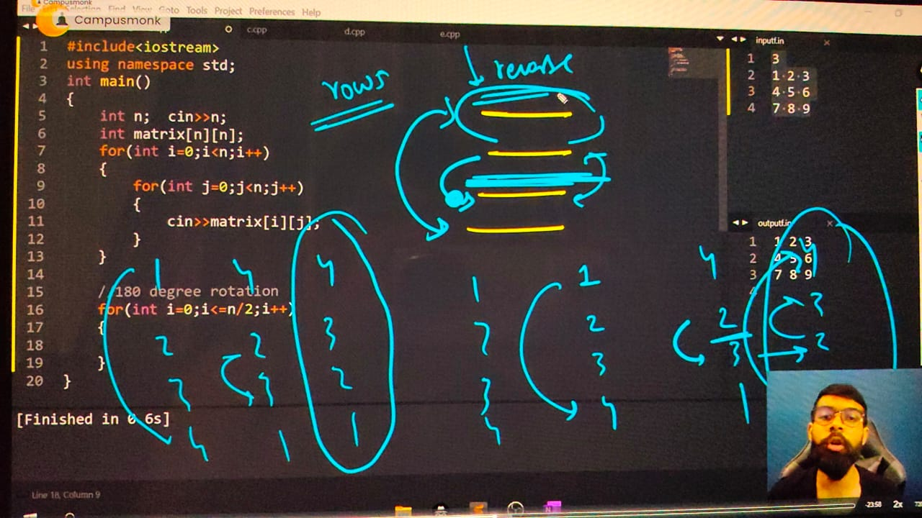

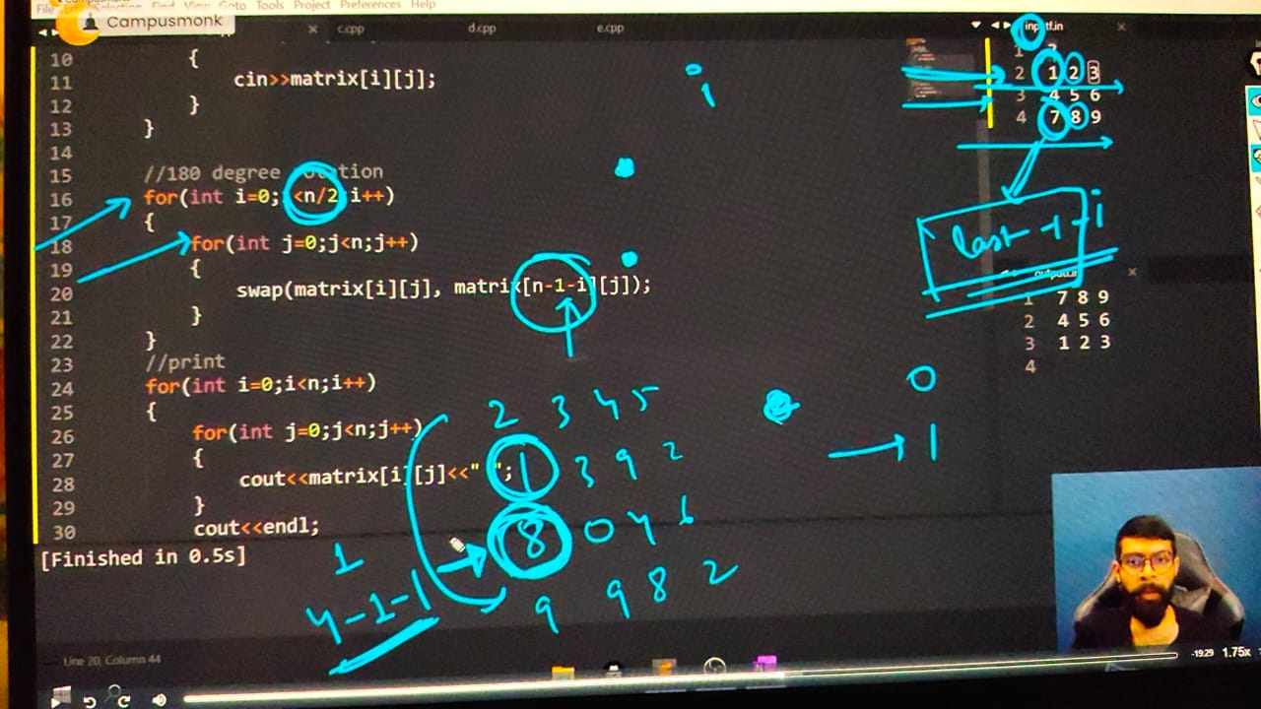

    // int n, m;

    // cout << "ENter the no. of Roews and Columns you want" << endl;

    // cin >> n >> m;

    // int matrix[n][m];

    // cout << "Now insert the matrix elements, mention you favourite Angel numbers " << endl;

    // for (int i = 0; i < n; i++)

    // {

    //     for (int j = 0; j < m; j++)

    //     {

    //         cin >> matrix[i][j];

    //     }

    // }

    // cout << endl;

    // cout << "So, the entered Array Matrix is - " << endl;

    // for (int i = 0; i < n; i++)

    // {

    //     for (int j = 0; j < m; j++)

    //     {

    //         cout << matrix[i][j] << " ";

    //     }

    //     cout << endl;

    // }

    // // For 180 degree rotation of AMatrix

    // /*

    // 📌 Logic - 180 rotate krne k liye samajh aaya  ki 1st row ko last row se swap krna he and 2nd rowe ko last 2nd se. or 1st and 3rd rows ke elements ko reverse krna he.

    //  - phle 1st row ko last se swap kiya phr 2nd row ko 2nd last se kiya to yh to pura reverse ho gya matrix which is 180 degree rotation

    //  - to agr n rowws he to n/2 times swap hoga - for reverse all rows

    //  - Remeber in matrix - bich waali row ko bich waali row se ya 1st ko last se - we use subsequent row which is alsywas given as -  n(TotalRows)-1-i(roww no)

    //  */

    // Row Swap

    // for (int i = 0; i < n / 2; i++)

    // {

    //     for (int j = 0; j < m; j++)

    //     {

    //         swap(matrix[i][j], matrix[n - 1 - i][j]);// n-1-i uses for get the subsequennt row of current row

    //     }

    // }

    // // Reverse bhi krna he elements ko so that could be in 180 deg

    // for (int i = 0; i < n; i++)

    // {

    // // Syntax for reverse - reverse(ARRAYNAME, ARRAYNAME+ARRAYSIZE)

    // // Modified syntax as per trials - reverse(ARRAYNAME+jaha tk reverse krna ho, ARRAYNAME+jaha se reverse krna ho)

    //     reverse(matrix[i], matrix[i]+n);

    // }

    // cout<<"The Matrix after Rotations is - "<<endl;

    // for (int i = 0; i < n; i++)

    // {

    //     for (int j = 0; j < m; j++)

    //     {

    //         cout << matrix[i][j] << " ";

    //     }

    //     cout << endl;

    // }

    /*

    ENter the no. of Roews and Columns you want

    3 3

    Now insert the matrix elements, mention you favourite Angel numbers

    1 2 3 4 5 6 7 8 9

    So, the entered Array Matrix is -

    1 2 3

    4 5 6

    7 8 9

    The Matrix after Rotations is -

    9 8 7

    6 5 4

    3 2 1

    */

// ____________ ____________

**// Qun 8 - Rotate the array by 90 CLW.**

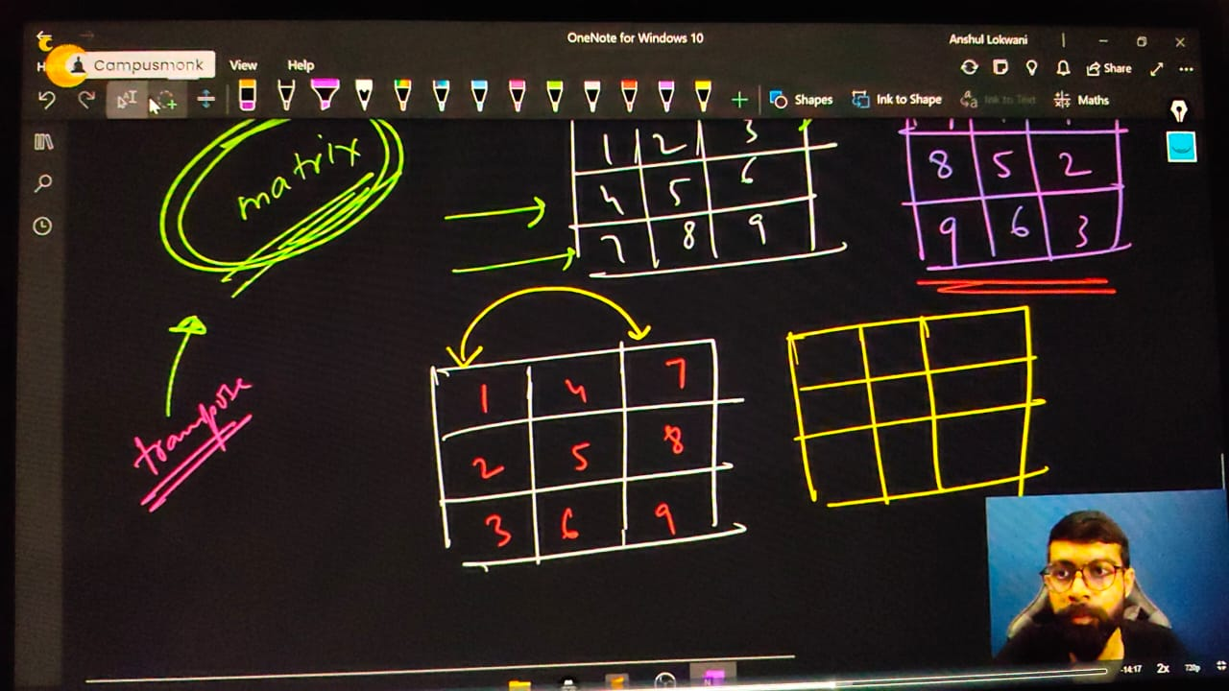

    // int n, m;

    // cout << "ENter the no. of Roews and Columns you want" << endl;

    // cin >> n >> m;

    // int matrix[n][m];

    // cout << "Now insert the matrix elements, mention you favourite Angel numbers " << endl;

    // for (int i = 0; i < n; i++)

    // {

    //     for (int j = 0; j < m; j++)

    //     {

    //         cin >> matrix[i][j];

    //     }

    // }

    // cout << endl;

    // cout << "So, the entered Array Matrix is - " << endl;

    // for (int i = 0; i < n; i++)

    // {

    //     for (int j = 0; j < m; j++)

    //     {

    //         cout << matrix[i][j] << " ";

    //     }

    //     cout << endl;

    // }

    // /*

    // 📌 Logic - 1) ro to column from last to 1st column

    // OR 2) take traspose and then swap columns

    // */

    // // Tanspose Mat -

    // for (int i = 0; i < n; i++)

    // {

    //     for (int j = i; j < n; j++)

    //     {

    //         swap(matrix[i][j], matrix[j][i]);

    //     }

    // }

    // // cout<<"The ranspse mat is - "<<endl;

    // // for (int i = 0; i < n; i++)

    // // {

    // //     for (int j = 0; j < m; j++)

    // //     {

    // //         cout << matrix[i][j] << " ";

    // //     }

    // //     cout << endl;

    // // }

    // // Now swap the columns. Column 1 with column 3 and 2nd column with 2nd last column

    // // So for it reverse the columns

    // for (int j = 0; j < m; j++)

    // {

    //     reverse(matrix[j], matrix[j]+n);

    // }

    // OR using -colun swap

    // for (int i = 0; i < n/2; i++)

    // {

    //     for (int j = 0; j < n; j++)

    //     {

    //         swap(matrix[j][i], matrix[j][n-1-i]);

    //     }

    // }

    // cout<<"So The Matrix after 90 degree rotation clw is "<<endl;

    // for (int i = 0; i < n; i++)

    // {

    //     for (int j = 0; j < m; j++)

    //     {

    //         cout << matrix[i][j] << " ";

    //     }

    //     cout << endl;

    // }

    /*

    ENter the no. of Roews and Columns you want

    3 3

    Now insert the matrix elements, mention you favourite Angel numbers

    1 2 3 4 5 6 7 8 9

    So, the entered Array Matrix is -

    1 2 3

    4 5 6

    7 8 9

    So The Matrix after 90 degree rotation clw is

    7 4 1

    8 5 2

    9 6 3

    */

// ____________ ____________ ____________ ____________ ____________

**// Qun 9 - Rotate the array by 90 ACLW.**

    // int n, m;

    // cout << "ENter the no. of Roews and Columns you want" << endl;

    // cin >> n >> m;

    // int matrix[n][m];

    // cout << "Now insert the matrix elements, mention you favourite Angel numbers " << endl;

    // for (int i = 0; i < n; i++)

    // {

    //     for (int j = 0; j < m; j++)

    //     {

    //         cin >> matrix[i][j];

    //     }

    // }

    // cout << endl;

    // cout << "So, the entered Array Matrix is - " << endl;

    // for (int i = 0; i < n; i++)

    // {

    //     for (int j = 0; j < m; j++)

    //     {

    //         cout << matrix[i][j] << " ";

    //     }

    //     cout << endl;

    // }

    // /*

    // 📌 Logic - 1) row to column from 1st to last in reverse order of elements

    // OR 2) take traspose and then swap Rows

    // */

    // // Tanspose Mat -

    // for (int i = 0; i < n; i++)

    // {

    //     for (int j = i; j < n; j++)

    //     {

    //         swap(matrix[i][j], matrix[j][i]);

    //     }

    // }

    // // cout << "The Transpose matrix is - " << endl;

    // // for (int i = 0; i < n; i++)

    // // {

    // //     for (int j = 0; j < m; j++)

    // //     {

    // //         cout << matrix[i][j] << " ";

    // //     }

    // //     cout << endl;

    // // }

    // //Now swap the rows to get the matrix rotation by 90 degress in ACW Manner -

    // for (int i = 0; i < n / 2; i++)

    // {

    //     for (int j = 0; j < m; j++)

    //     {

    //         swap(matrix[i][j], matrix[n - 1 - i][j]);// n-1-i uses for get the subsequennt row of current row

    //     }

    // }

    // cout<<"and, finally 90 deg rotated Matrix by ACW"<<endl;

    // for (int i = 0; i < n; i++)

    // {

    //     for (int j = 0; j < m; j++)

    //     {

    //         cout << matrix[i][j] << " ";

    //     }

    //     cout << endl;

    // }

/*

ENter the no. of Roews and Columns you want

3 3

Now insert the matrix elements, mention you favourite Angel numbers

1 2 3 4 5 6 7 8 9

So, the entered Array Matrix is -

1 2 3

4 5 6

7 8 9

and, finally 90 deg rotated Matrix by ACW

3 6 9

2 5 8

1 4 7

*/

// ____________ ____________ ____________ ____________ ____________ ____________ ____________ ____________ ____________ ____________ ____________

}

**Binary Search Concept –**

Binary Search -

1 - Binary Search for sorted array - increasing & decreasing

2 - sum of 2 elements of array equal to target elemnt thern print yes, using Binary Search concept -

**Qun – Write down a program for Binary Search and its implementation for Sorted Array.**

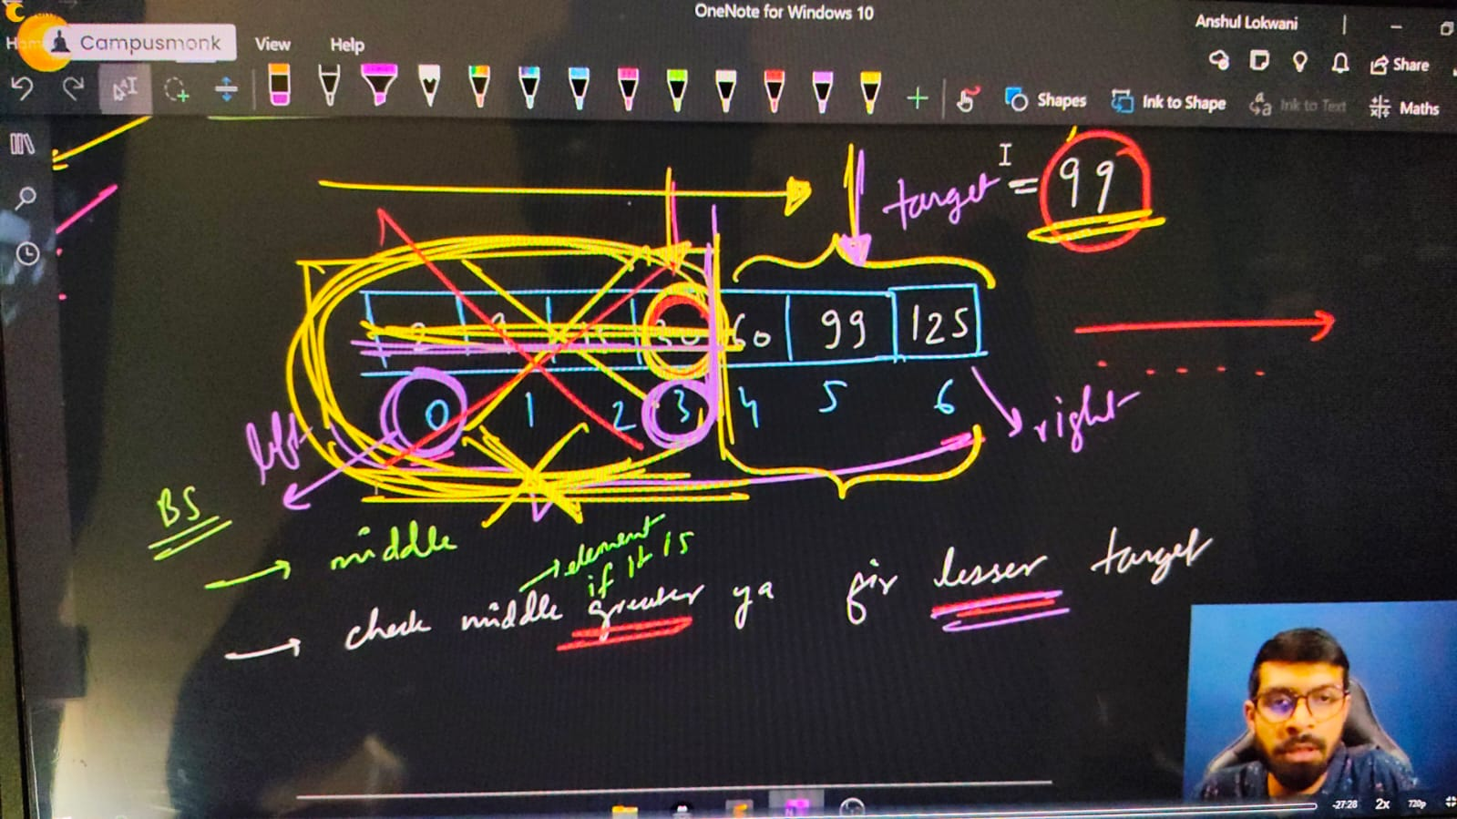

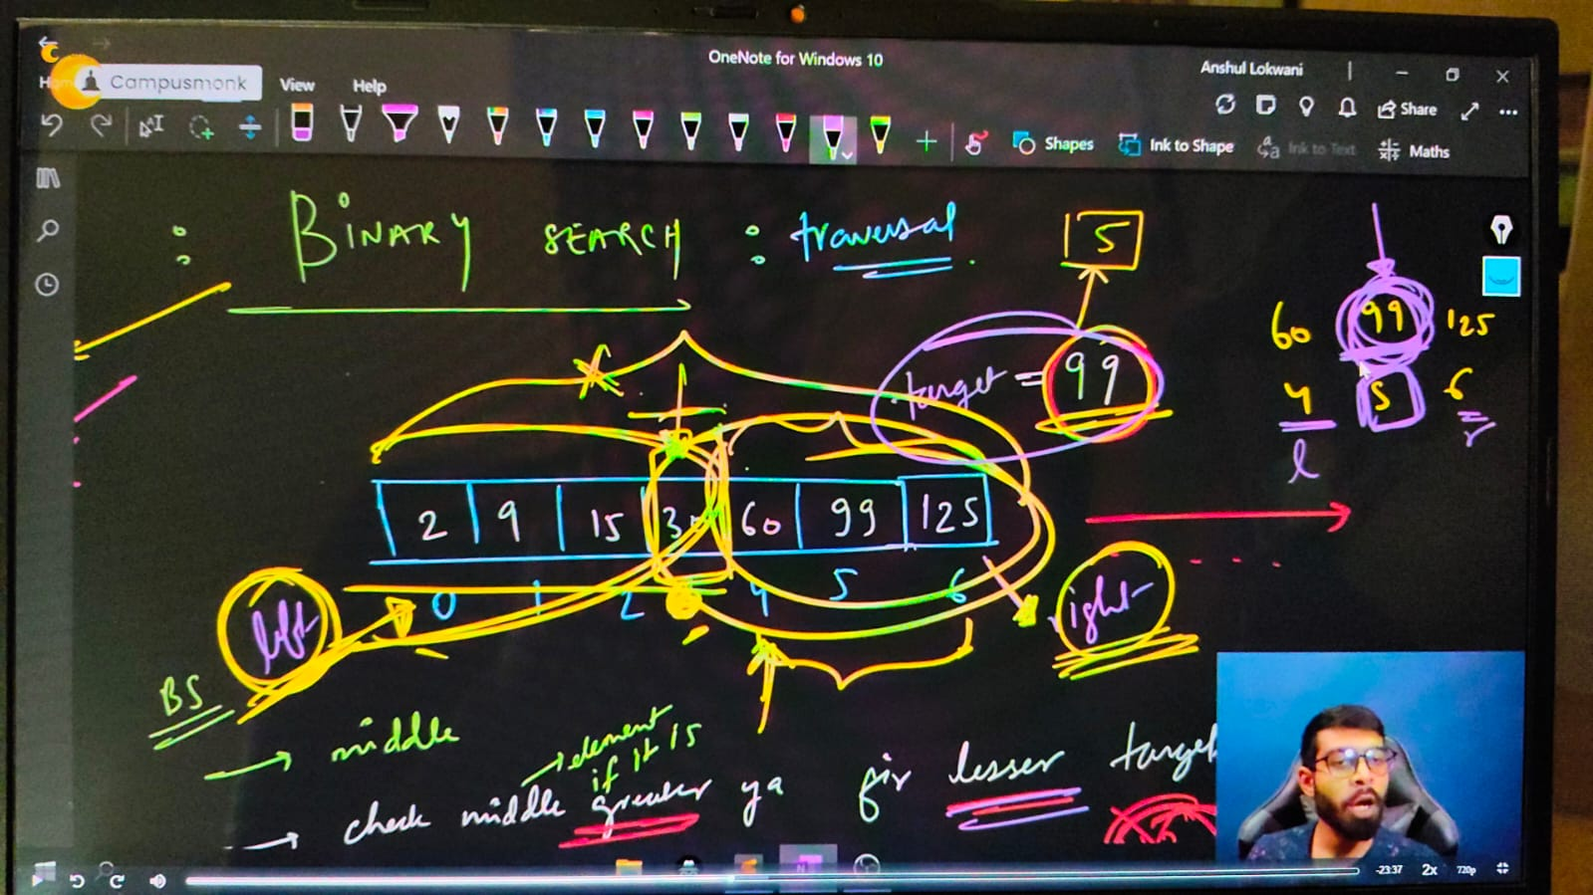

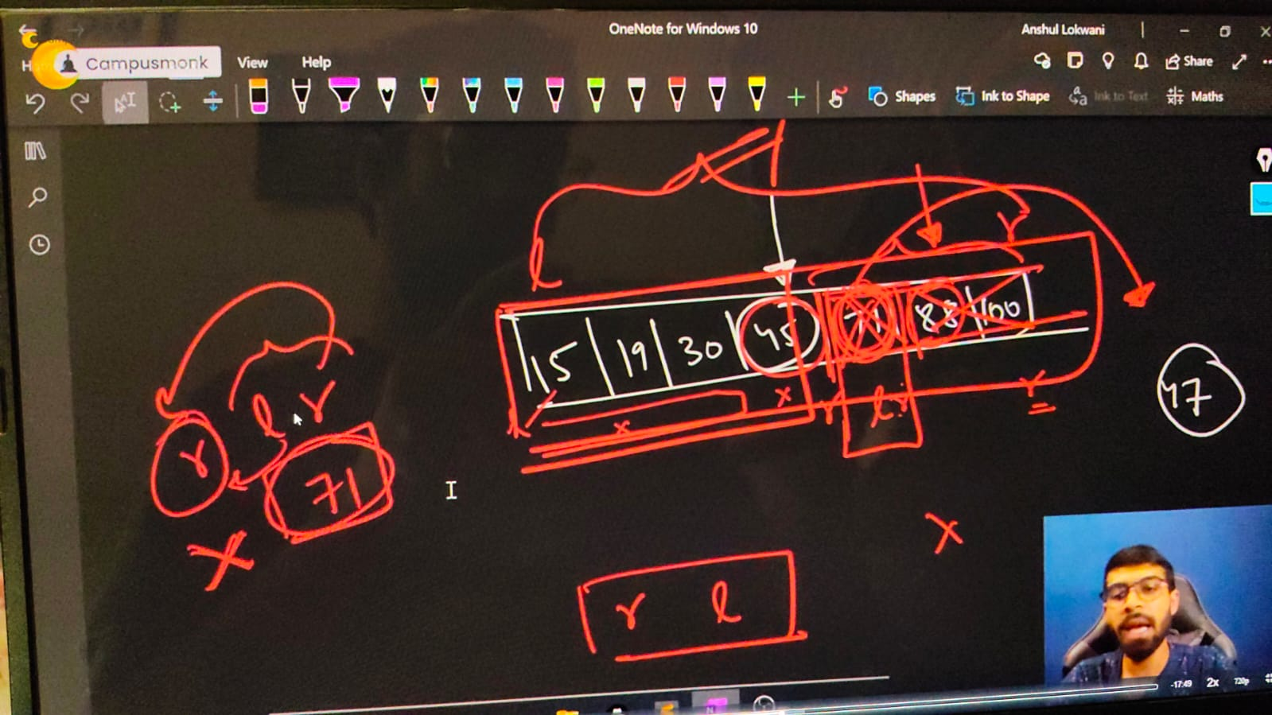

#include <bits/stdc++.h>

// #include <iostream>

// #include<algorithm>

// #include<climits>

// #include<string>

// #include<cctype>

using namespace std;

int main()

{

**// Binary Search Concept - Conditionn - Must be for Sorted Arraay only.  All elem,ents /w Lfet and ight is known as Search Space**

    // int n;

    // cout << "Enter the size of array - ";

    // cin >> n;

    // int arr[n];

    // cout << "MEntion the array values you want tot inserett - " << endl;

    // for (int i = 0; i < n; i++)

    // {

    //     cin >> arr[i];

    // }

    // cout << endl;

    // cout << "So, your enteres aray is - " << endl;

    // for (int i = 0; i < n; i++)

    // {

    //     cout << arr[i] << " ";

    // }

    // cout << endl;

    // int targetelement;

    // cout << "Now, let me knw what is your Targeted Element" << endl;

    // cin >> targetelement;

    // // Bianry Search process -

    // int left = 0, right = n - 1;

    // while (left <= right)

    // {

    //     int mid = (left + right) / 2;

    //     if (arr[mid] == targetelement)

    //     {

    //         cout << "Element is here and found at - " << " " << mid << endl;

    //         return 0;

    //     }

    //     else if (arr[mid]>targetelement)

    //     {

    //         right = mid-1;

    //     }

    //     else

    //     {

    //         left = mid+1;

    //     }

    // }

    // cout<<"Element not found braddy"<<endl;

    /*

    Enter the size of array - 7

    MEntion the array values you want tot inserett -

    1 2 3 4 5 6 7

    So, your enteres aray is -

    1 2 3 4 5 6 7

    Now, let me knw what is your Targeted Element

    5

    Element is here and found at -  4

    Enter the size of array - 7

    MEntion the array values you want tot inserett -

    1 2 3 4 5 6 7

    So, your enteres aray is -

    1 2 3 4 5 6 7

    Now, let me knw what is your Targeted Element

    8

    Element not found braddy

    Enter the size of array - 10

    MEntion the array values you want tot inserett -

    89 78 45 56 12 23 32 21 65 99

    So, your enteres aray is -

    89 78 45 56 12 23 32 21 65 99

    Now, let me knw what is your Targeted Element

    12

    Element is here and found at -  4

    */

    // T.C - of BS  is given by (log n). For n operations juts half - because either in Ight or in Left

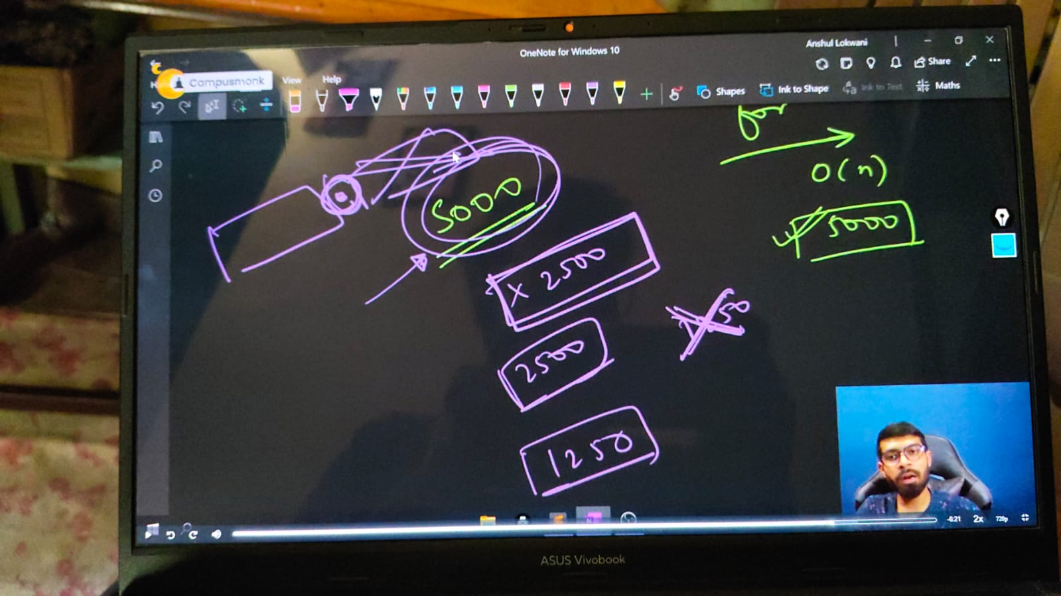

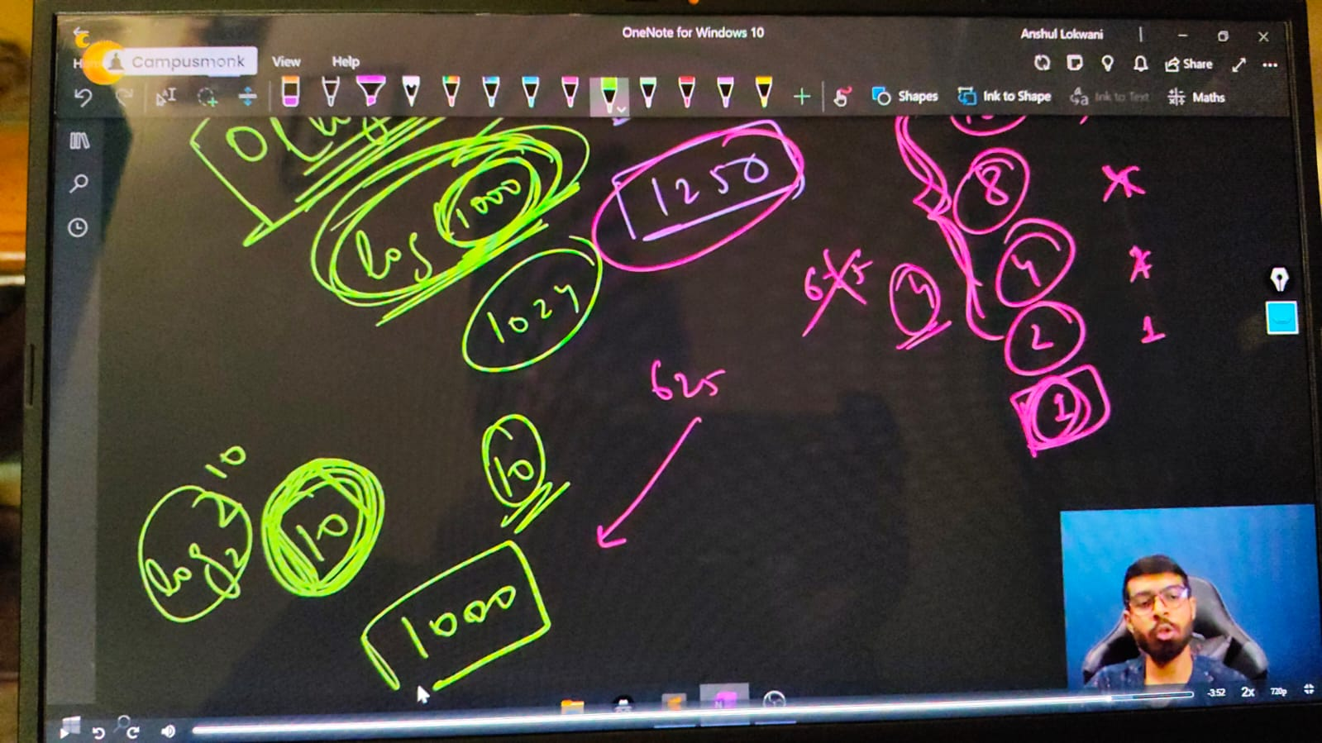

// ____________ ____________

**// Binary Search for the decreasing oder of array elements -**

    //   int n;

    // cout << "Enter the size of array - ";

    // cin >> n;

    // int arr[n];

    // cout << "MEntion the array values you want tot inserett - " << endl;

    // for (int i = 0; i < n; i++)

    // {

    //     cin >> arr[i];

    // }

    // cout << endl;

    // cout << "So, your enteres aray is - " << endl;

    // for (int i = 0; i < n; i++)

    // {

    //     cout << arr[i] << " ";

    // }

    // cout << endl;

    // int targetelement;

    // cout << "Now, let me knw what is your Targeted Element" << endl;

    // cin >> targetelement;

    // // Bianry Search process -

    // int left = 0, right = n - 1;

    // while (left <= right)

    // {

    //     int mid = (left + right) / 2;

    //     if (arr[mid] == targetelement)

    //     {

    //         cout << "Element is here and found at - " << " " << mid << endl;

    //         return 0;

    //     }

    //     else if (arr[mid]>targetelement)

    //     {

    //         left = mid+1;

    //     }

    //     else

    //     {

    //         right = mid-1;

    //     }

    // }

    // cout<<"Element not found braddy"<<endl;

    /*

    Enter the size of array - 7

    MEntion the array values you want tot inserett -

    7 6 5 4 3 2 1

    So, your enteres aray is -

    7 6 5 4 3 2 1

    Now, let me knw what is your Targeted Element

    3

    Element is here and found at -  4

    Enter the size of array - 7

    MEntion the array values you want tot inserett -

    7 6 5 4 3 2 1

    So, your enteres aray is -

    7 6 5 4 3 2 1

    Now, let me knw what is your Targeted Element

    6

    Element is here and found at -  1

    Enter the size of array - 7

    MEntion the array values you want tot inserett -

    7 6 5 4 3 2 1

    So, your enteres aray is -

    7 6 5 4 3 2 1

    Now, let me knw what is your Targeted Element

    56

    Element not found braddy

    */

    // ____________ ____________ ____________ ____________ ____________

**//Array Qun 7 using Binary Search- If sum of 2 elements of array equal to target elemnt thern print yes, using Binary Search concept –**

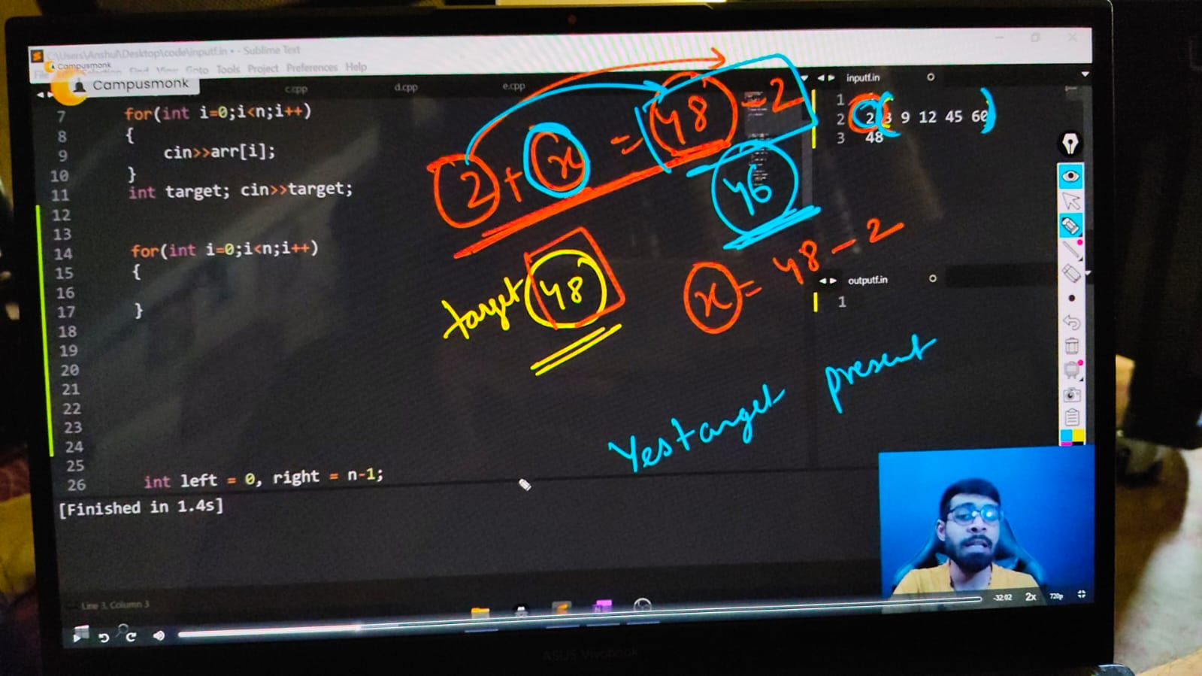

    // 📌- when we solved this concept using 2 for loops then the complexoty was around n^2. so now for decreasingnthis complexity and making iteasy we're tryign with bonary search techniques

    // int n;

    // cout << "Enter the size of array - ";

    // cin >> n;

    // int arr[n];

    // cout << "MEntion the array values you want tot inserett - " << endl;

    // for (int i = 0; i < n; i++)

    // {

    //     cin >> arr[i];

    // }

    // cout << endl;

    // cout << "So, your enteres aray is - " << endl;

    // sort(arr, arr+n);//Sorting the array because what if user coudn;t privde us a sorted arrayu

    // for (int i = 0; i < n; i++)

    // {

    //     cout << arr[i] << " ";

    // }

    // cout << endl;

    // int target;

    // cout << "Now, let me knw what is your Targeted Element" << endl;

    // cin >> target;

    // for (int i = 0; i < n; i++)

    // {

    //     // 📌 Logic - a+b=target. i+find=target. jis elelmtnpr ho use target se substract kr do, vo eleemnt mil jaayga

    //     int a = arr[i];

    //     int find = target - a;

    //     int left = i + 1, right = n - 1;

    //     // i+1 --------n-1

    //     while (left <= right)

    //     {

    //         int mid = (left + right) / 2;

    //         if (arr[mid] == find)

    //         {

    //             cout << "Yes elment's sum equate to target eleemnt" << endl;

    //             cout <<"and the elements are available at "<< i << " " << mid << endl;

    //             return 0;

    //         }

    //         else if(arr[mid]>find)

    //         {

    //             right = mid-1;

    //         }

    //         else

    //         {

    //             left = mid+1;

    //         }

    //     }

    // }

    // cout<<"Not found "<<endl;

/*

Enter the size of array - 5

MEntion the array values you want tot inserett -

10 45 32 98 78

So, your enteres aray is -

10 32 45 78 98

Now, let me knw what is your Targeted Element

42

Yes elment's sum equate to target eleemnt

and the elements are available at 0 1

*/

// T.C - for the given for loop it's O(n) & for Binary Search its O(logn) so total - O(n*logn)

// ____________ ____________ ____________ ____________ ____________

}